**Employee Management System**

1. **Overview**
   1. **What:**

* Employee Management System is an application that manages employee data within an organization, including details about employees, departments (e.g., Operations, IT, Accounting, Finance, Admin, HR), attendance, and payroll.
* It provides features such as viewing employee details, viewing and handling attendance details, viewing and handling leave details (e.g., apply leaves, assign leave application to the respective manager, approve leaves), on-boarding (adding new employees), off-boarding (removing resigned employees), updating personal details (e.g., contact number, address, blood group), and updating job-specific details (e.g., employee ID, role, salary, department, tenure, skillset, KPIs handled, performance scores).
* The application uses MySQL as the DBMS.
* This is a web-based application that runs on a browser and is accessible within the Local Area Network (LAN) of the organization.
  1. **Why:**
* This application is useful for any organization (e.g., IT & ITES companies, banks, insurance companies, restaurants, warehouses) with employees driving the business.
* It can be used to sort and filter employees based on performance scores and provide yearly salary hikes and promotions based on the budget.
  1. **How:**
* Backend: MySQL, SQL and Python
* Frontend: Streamlit

1. **Database Structure**

**EMS**

**Employee**

Emp_ID (Primary_Key)

Emp_Name

Password

Dept_ID

Role_ID

Contact_No

Email

Address

Date_of_Birth

Gender

Emergency_Contact

Joining_Date

Manager_ID

**Department**

Dept_ID (Primary_Key)

Dept_Name

Manager_ID

**Roles**

Role_ID (Primary_Key)

Role_Name

Role_Desc

**Attendance**

Att_Date

Emp_ID

Attendance_Status

**Leaves**

Leave_Date

Emp_ID

Approver_ID

Approver_Role

Approval_Status

**Payroll**

Emp_ID

Month_Year

Salary

Deductions

**Performance**

Financial_Year

Emp_ID

Number_Of_Projects

Score

**Projects**

Project_ID (Primary_Key)

Project_Name

Start_Date

End_Date

Dept_ID

Manager_ID

**Employee_Project**

Emp_ID

Project_ID

Role_in_Project

Hours_Spent

1. **Features and Roles**

**Employee (common to all):**

Mark Attendance

View Attendance Status

Mark Leave

View Individual Leaves

View Performance Details

View Projects

**Human Resource Management:**

View Employee

Add Employee

Delete Employee

Update Employee Details

Generate Monthly Payroll

Generate & Update Performance Data

**Department Head:**

Update Role

Change Department

Update Manager

Add Roles

**Manager:**

Leave Approval

Assign Projects

Update Employee Project

**Project Manager:**

Add Projects

Update Projects

1. **Screenshot of MySQL workbench, all the SQL commands and tables.**
   1. Employee table:

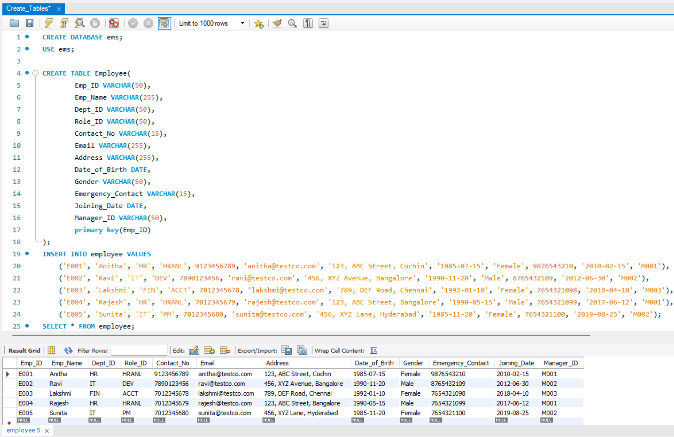

* 1. Department table:

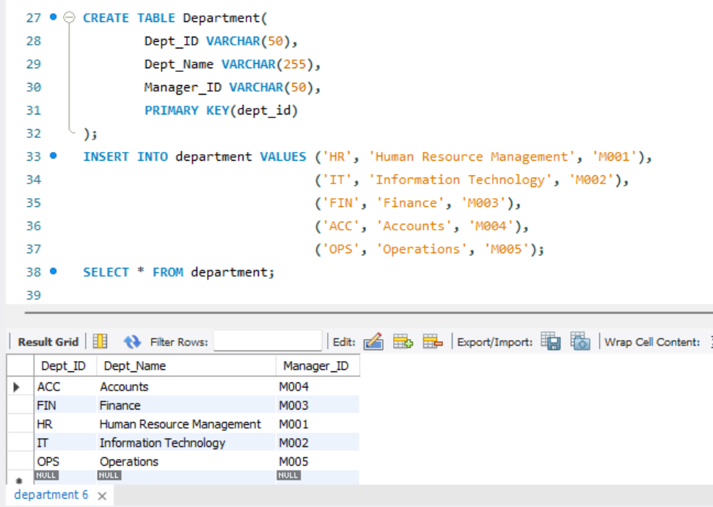

* 1. Roles table:

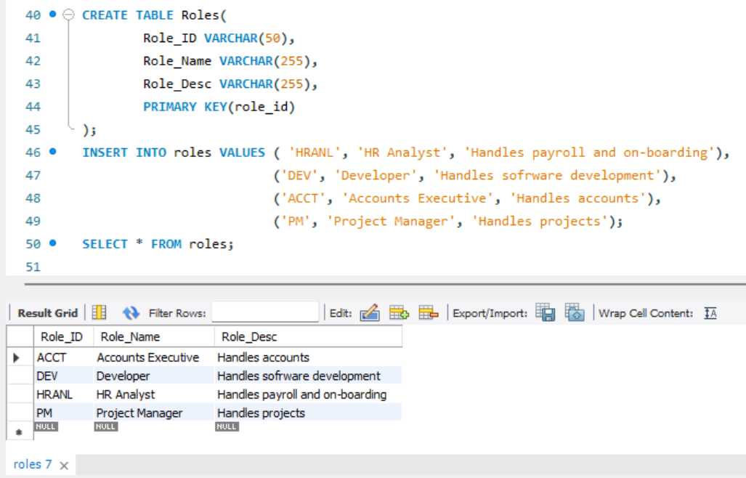

* 1. Attendance table:

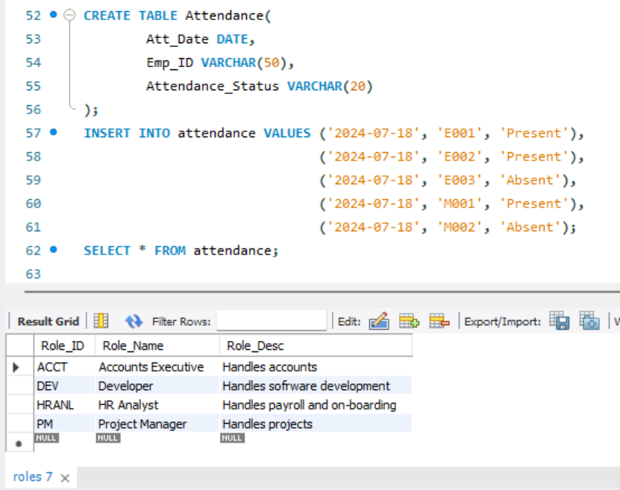

* 1. Leaves table:

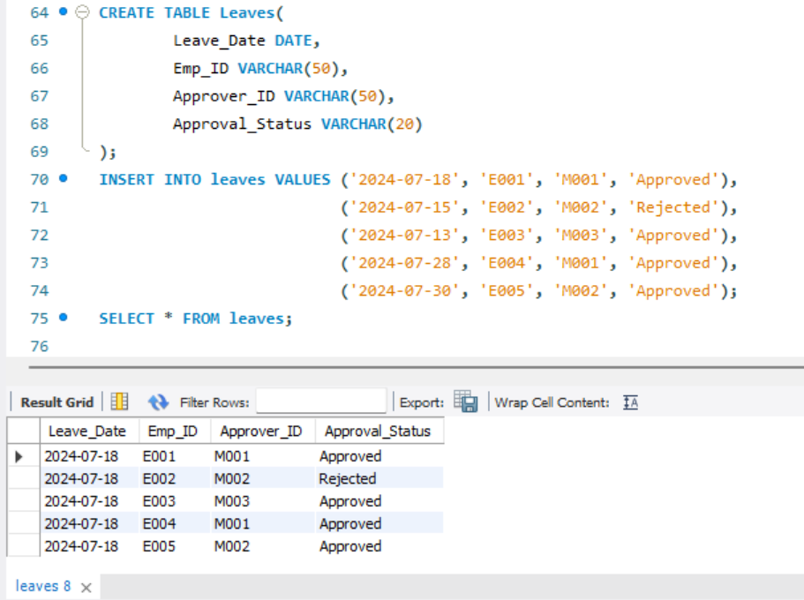

* 1. Payroll table:

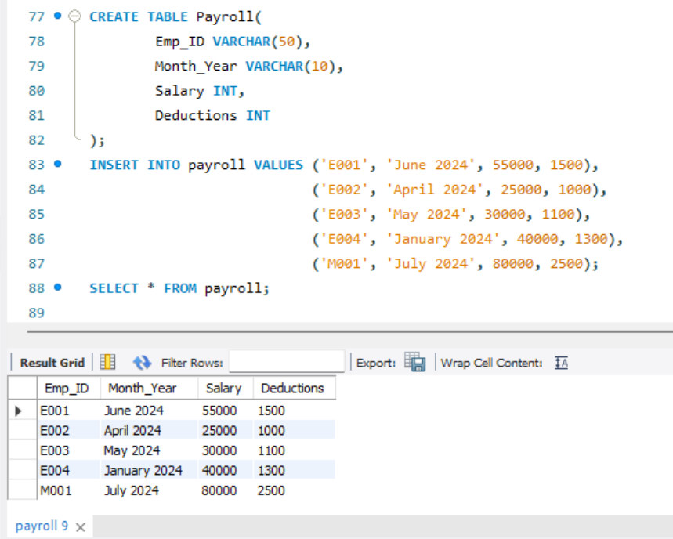

* 1. Performance table:

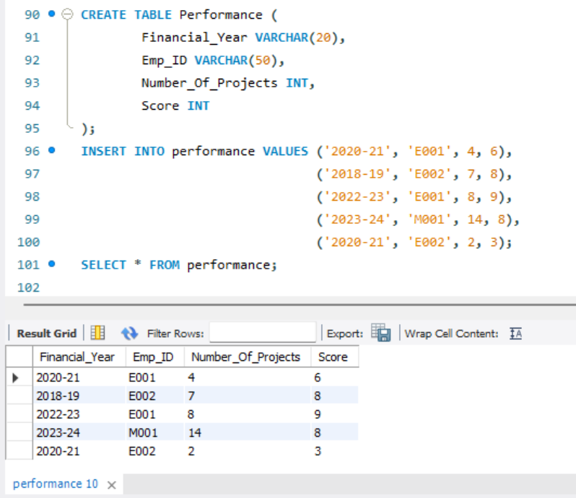

* 1. Projects table:

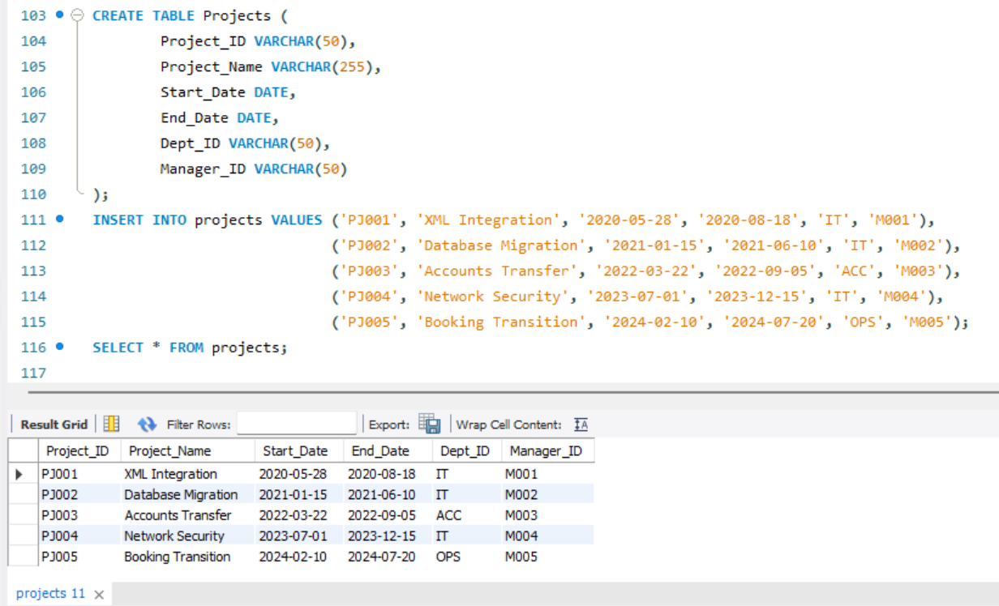

* 1. Employee_Project table:

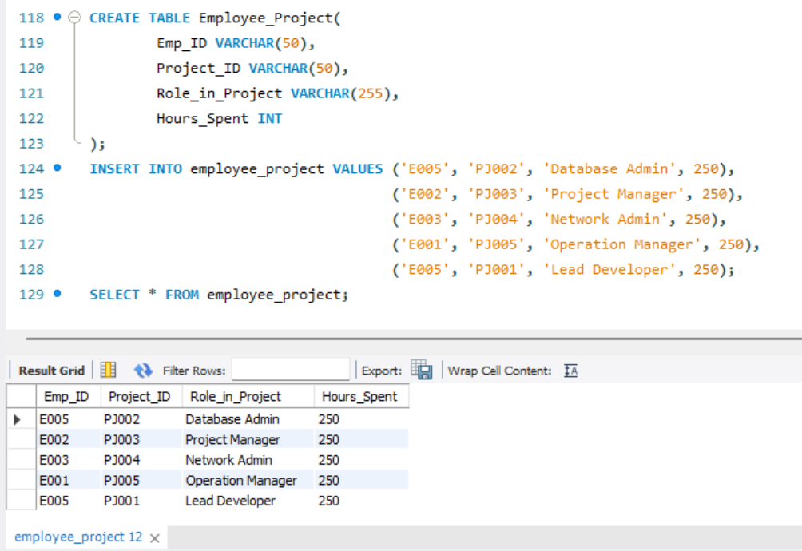

1. **Main streamlit python code**

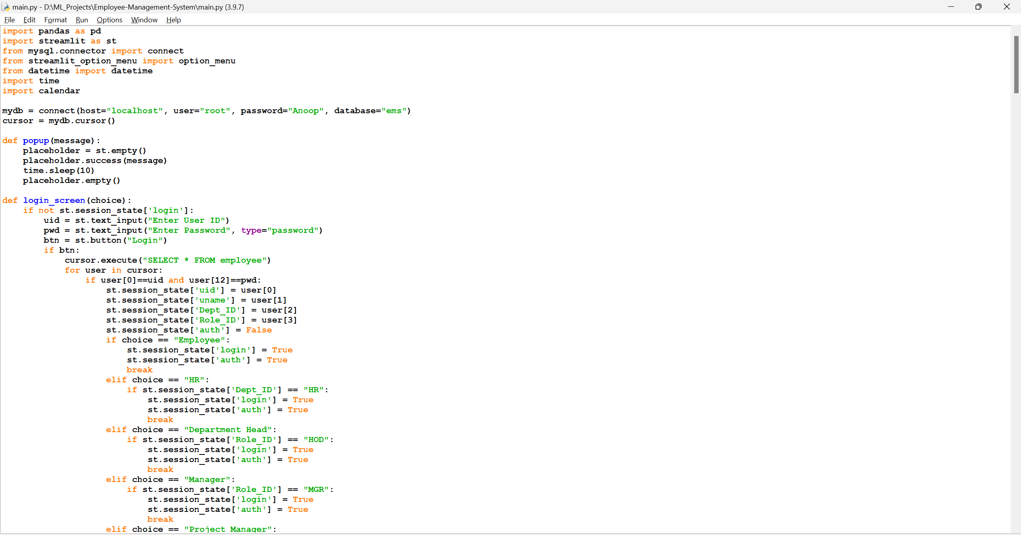

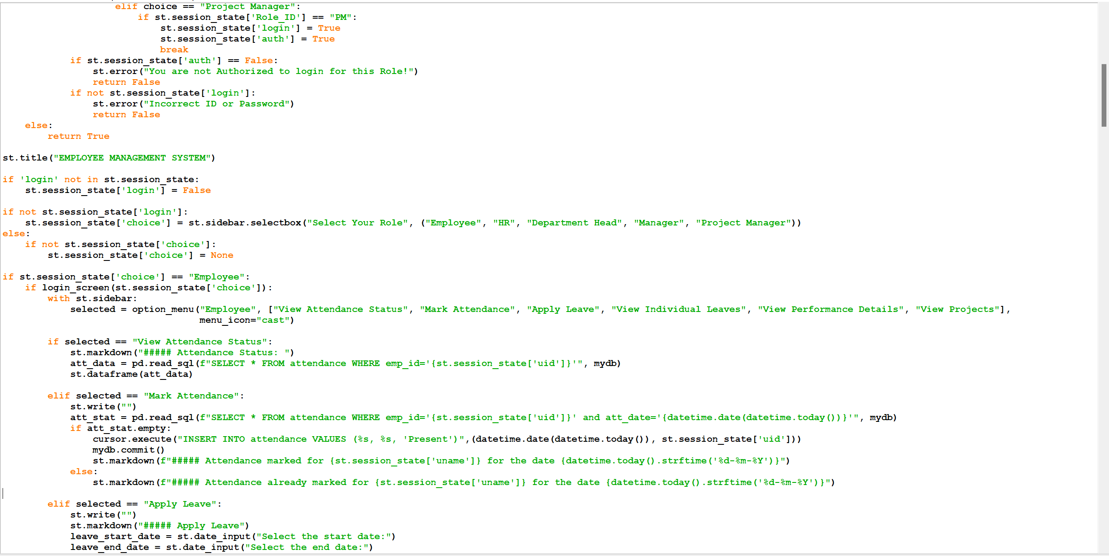

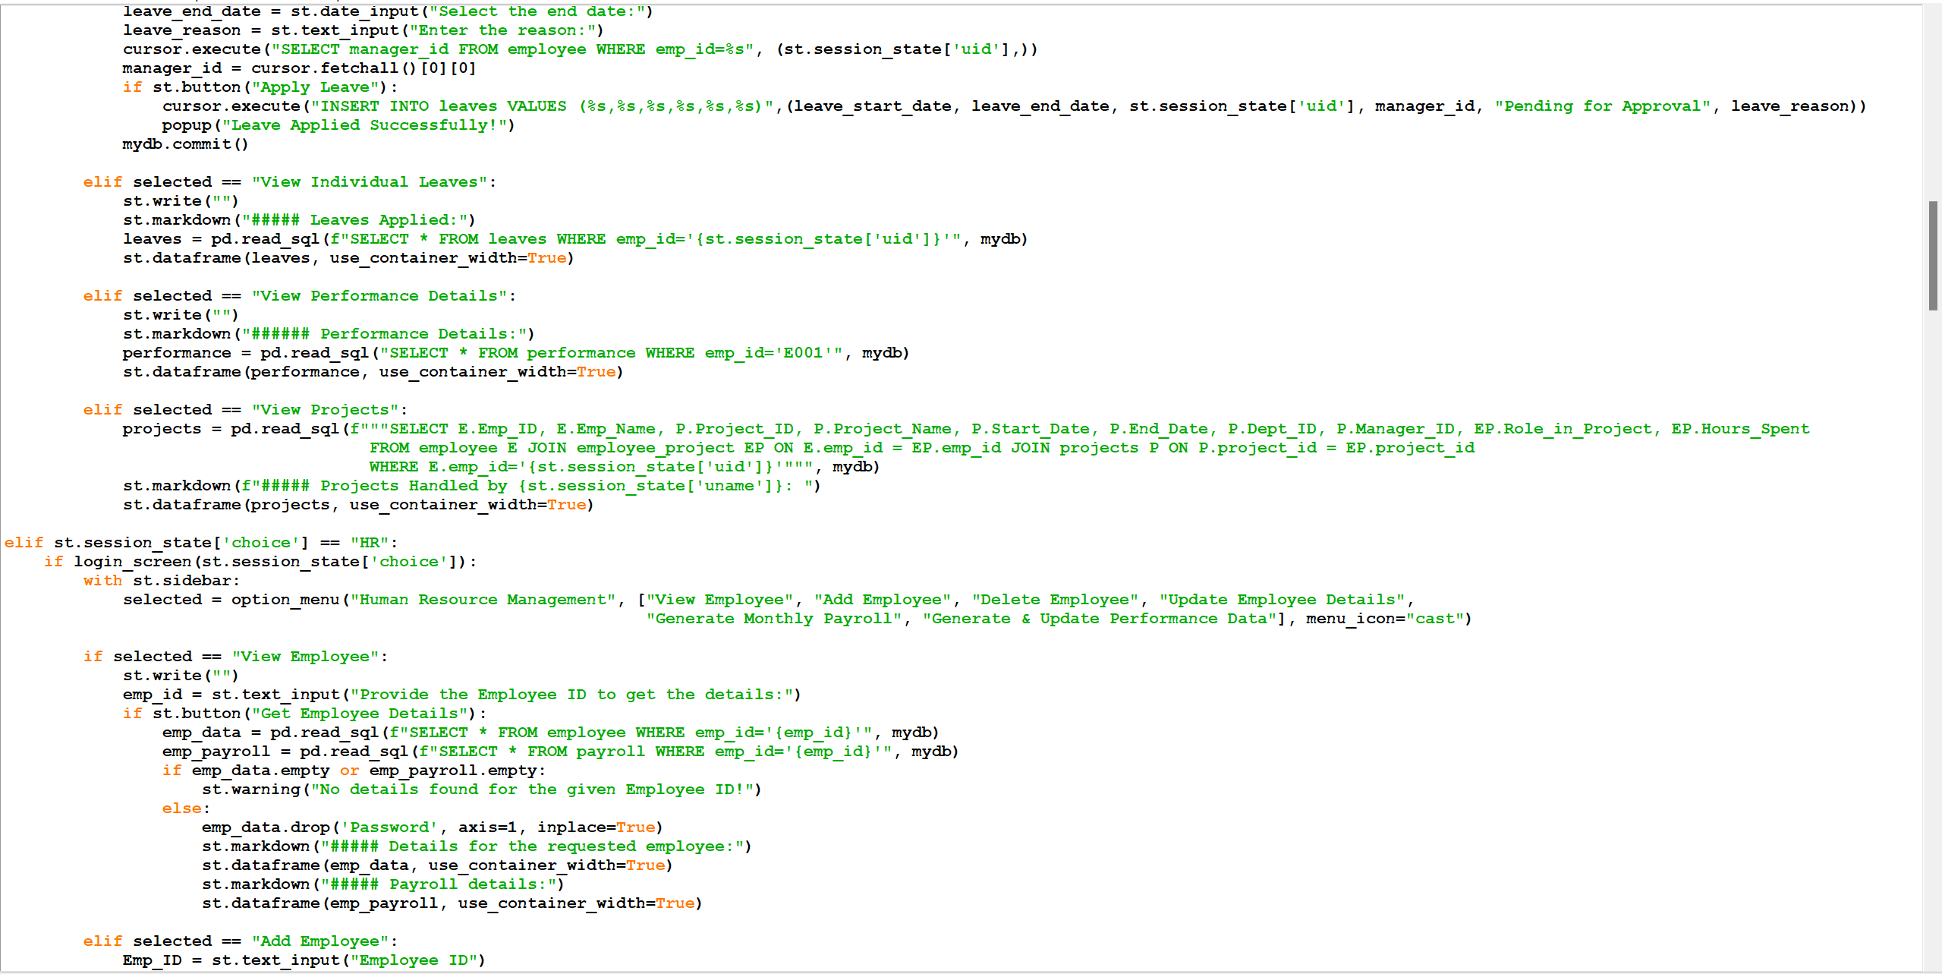

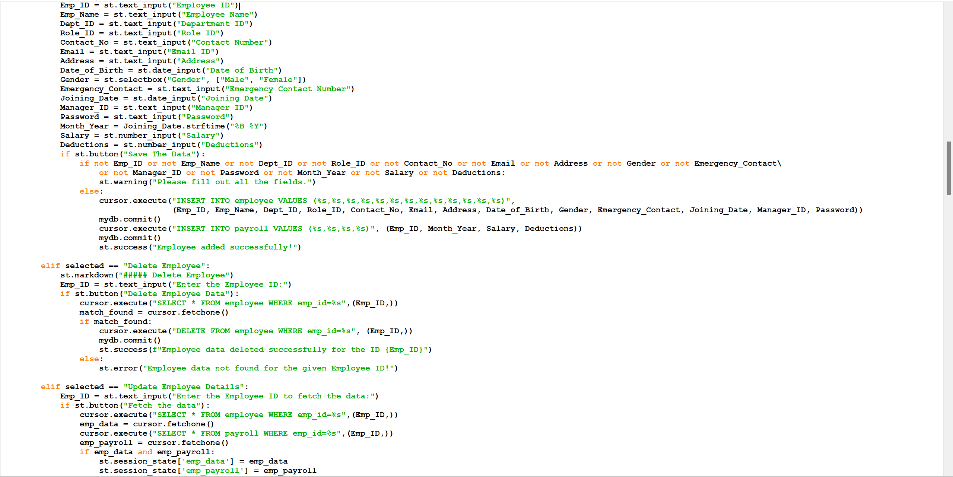

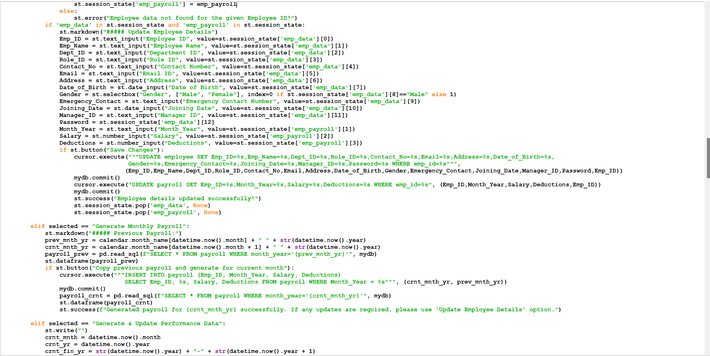

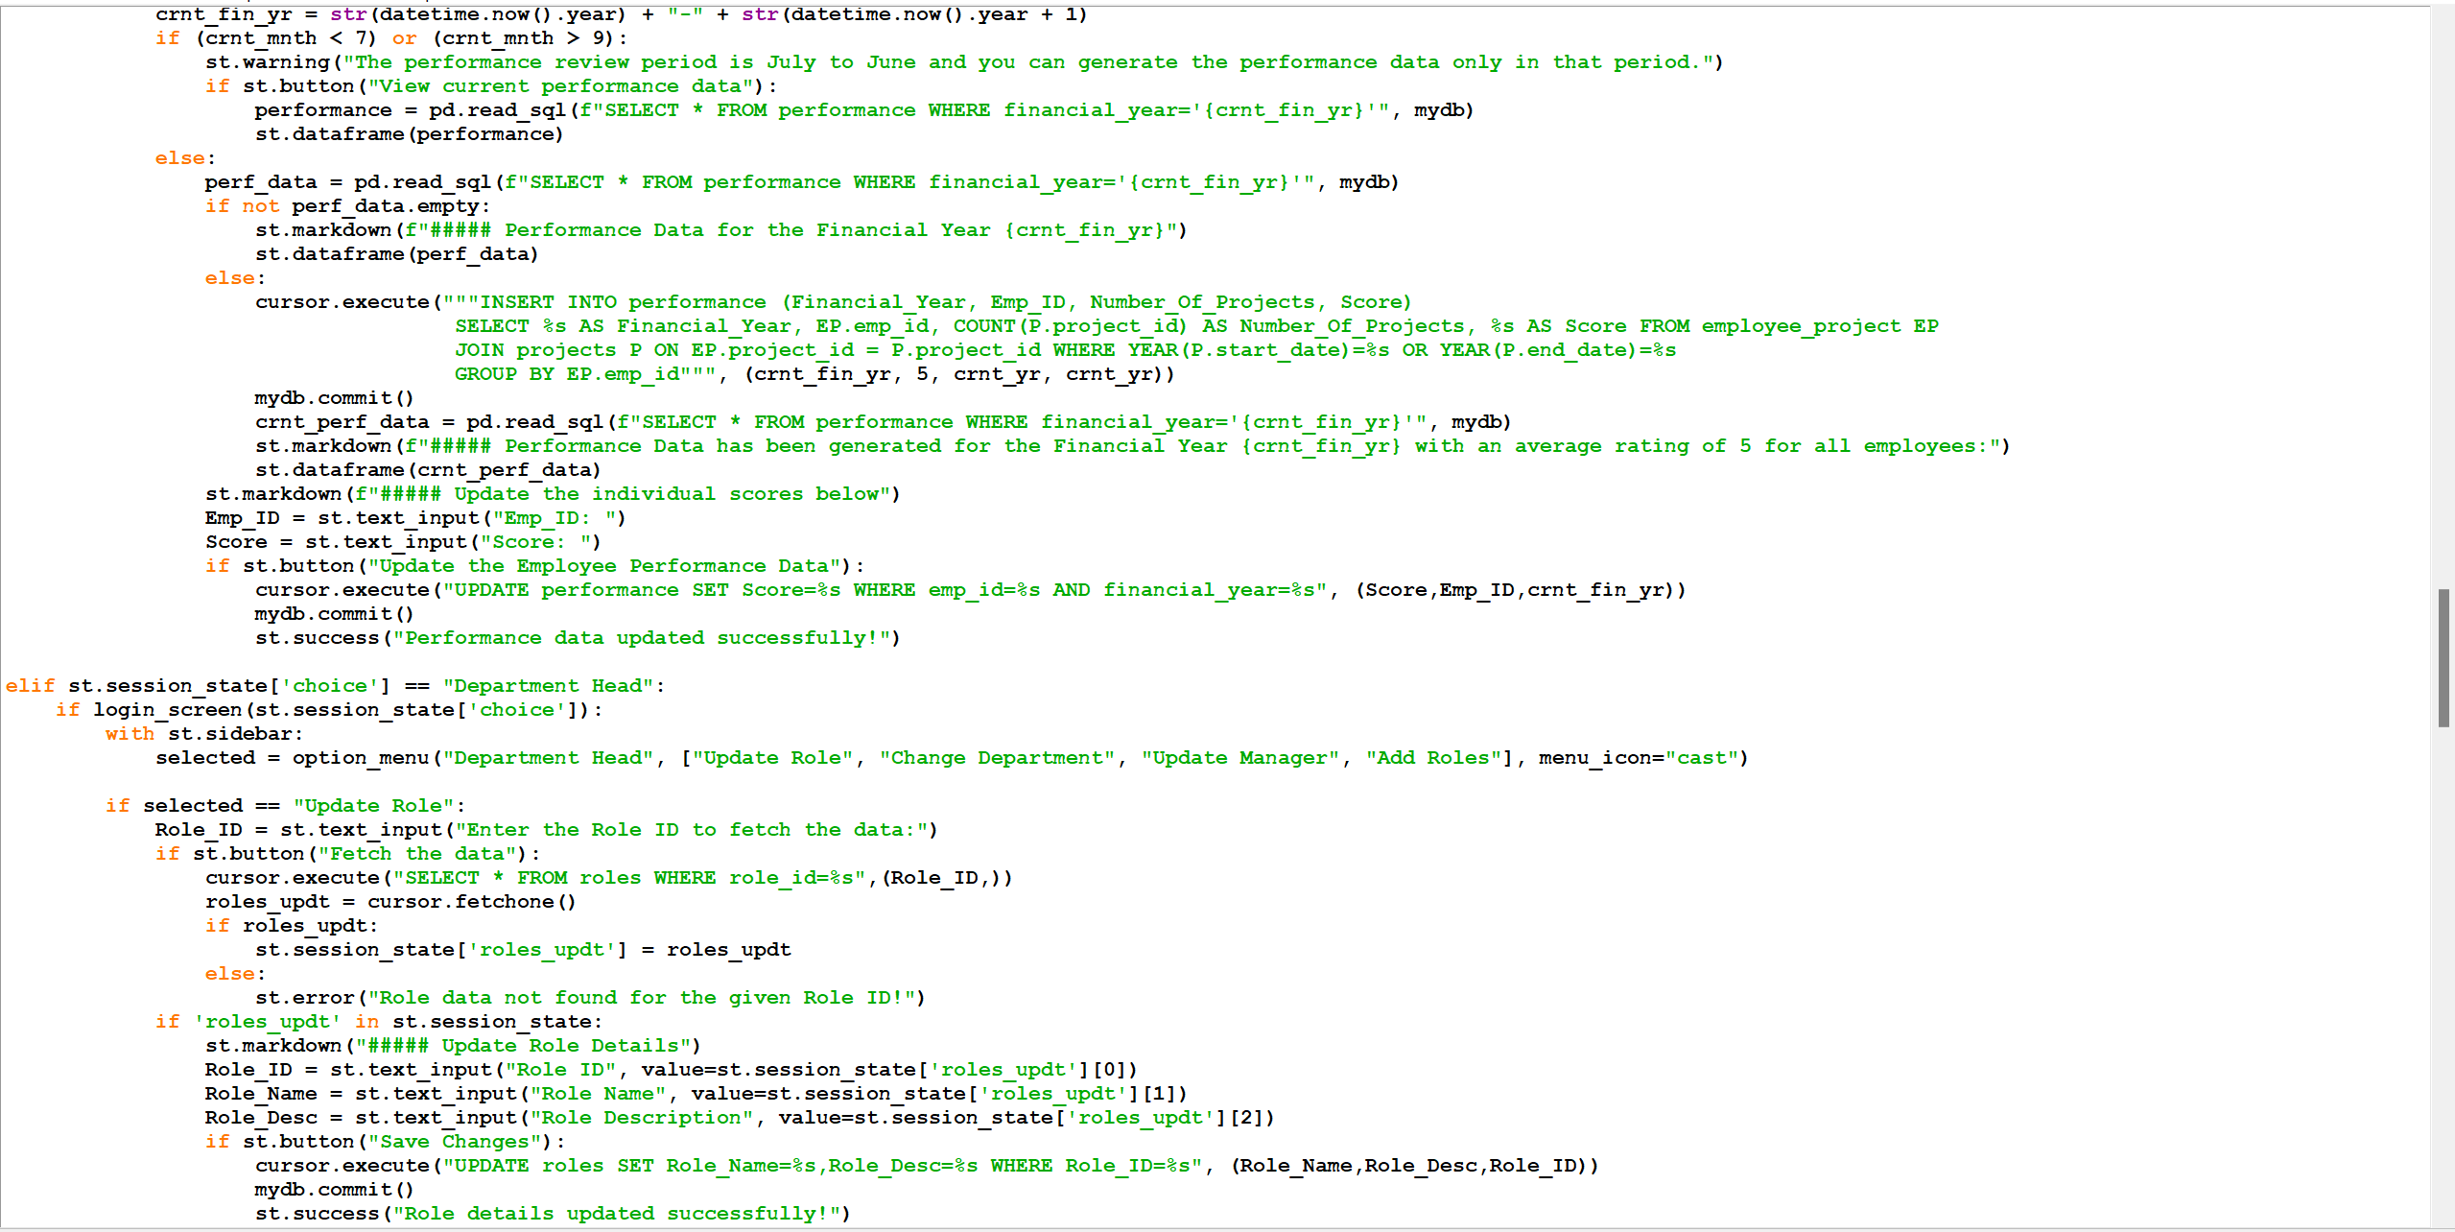

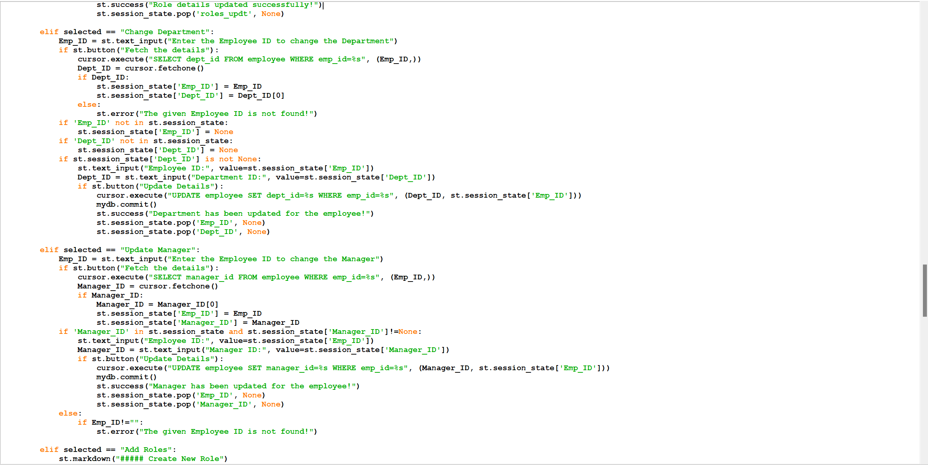

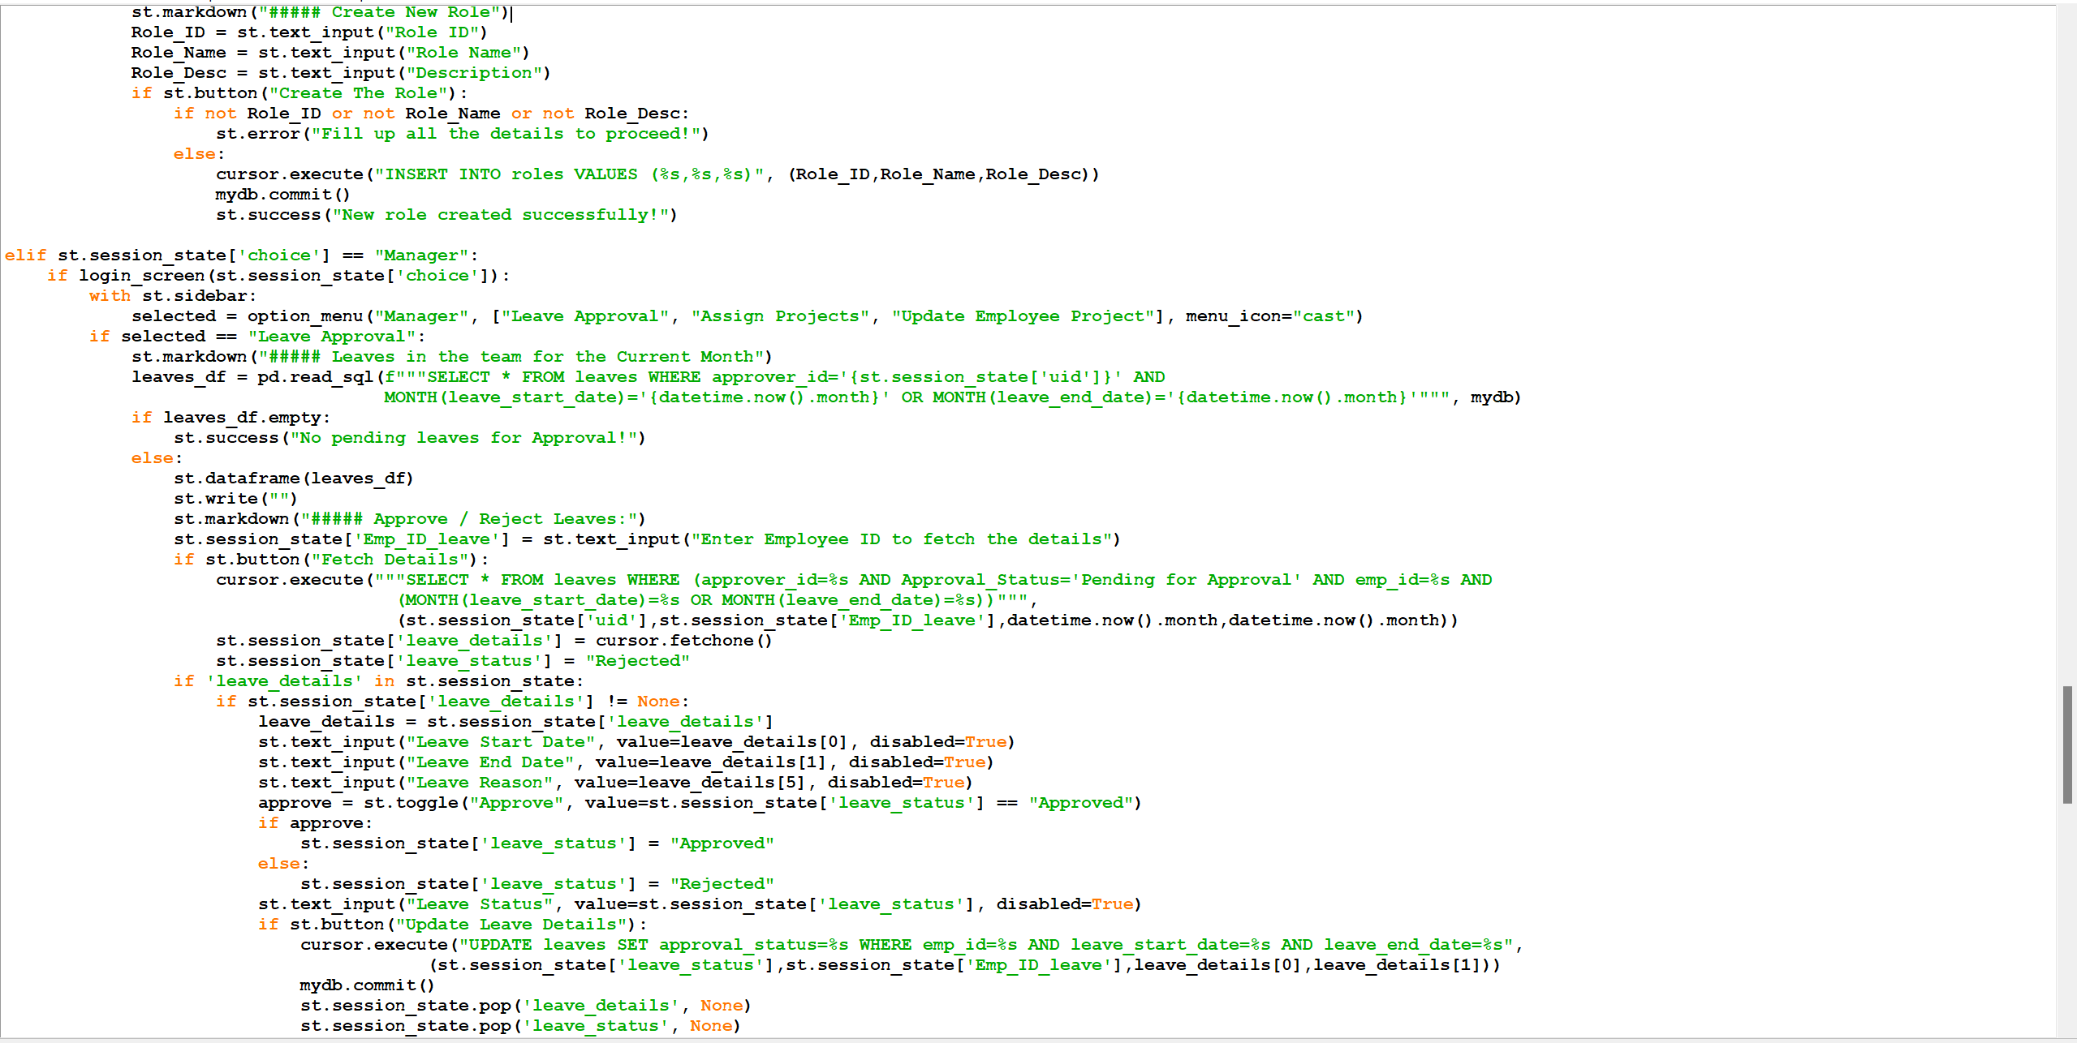

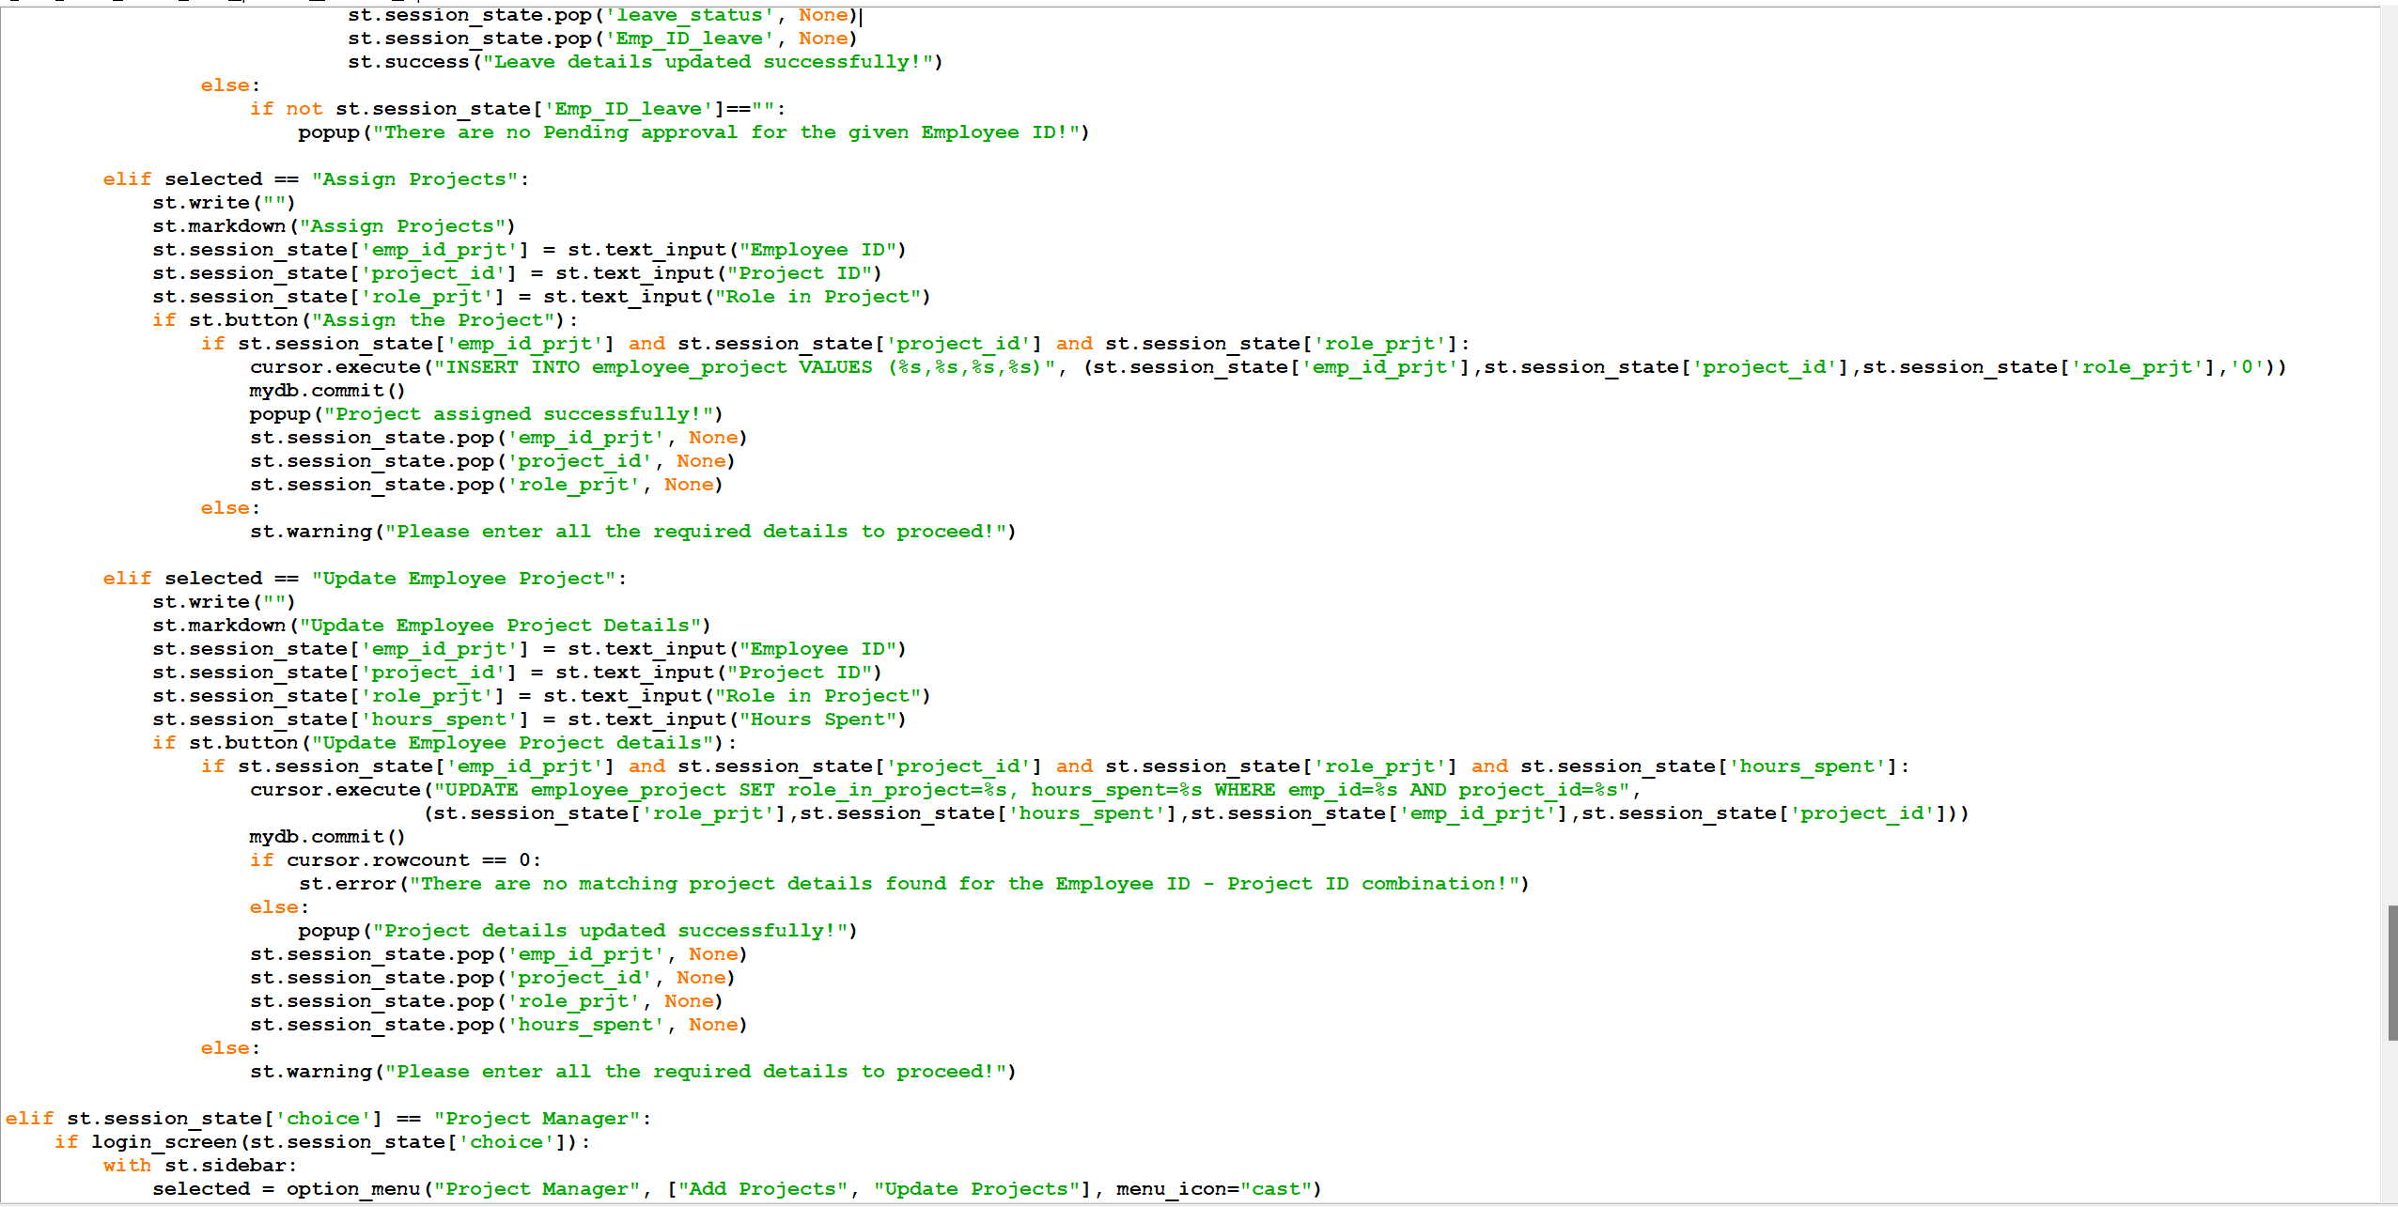

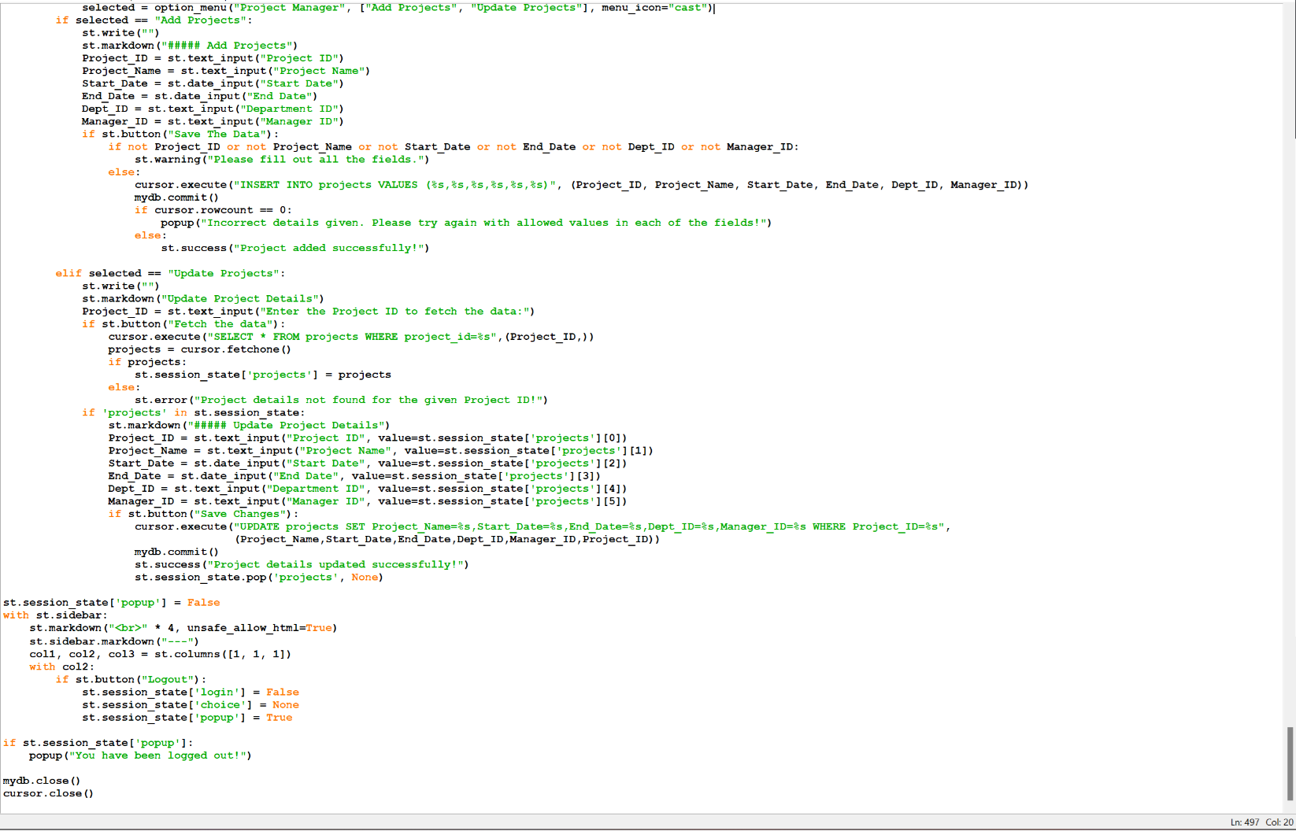

1. **Screenshots of streamlit application including all the features**
   1. Login screen:

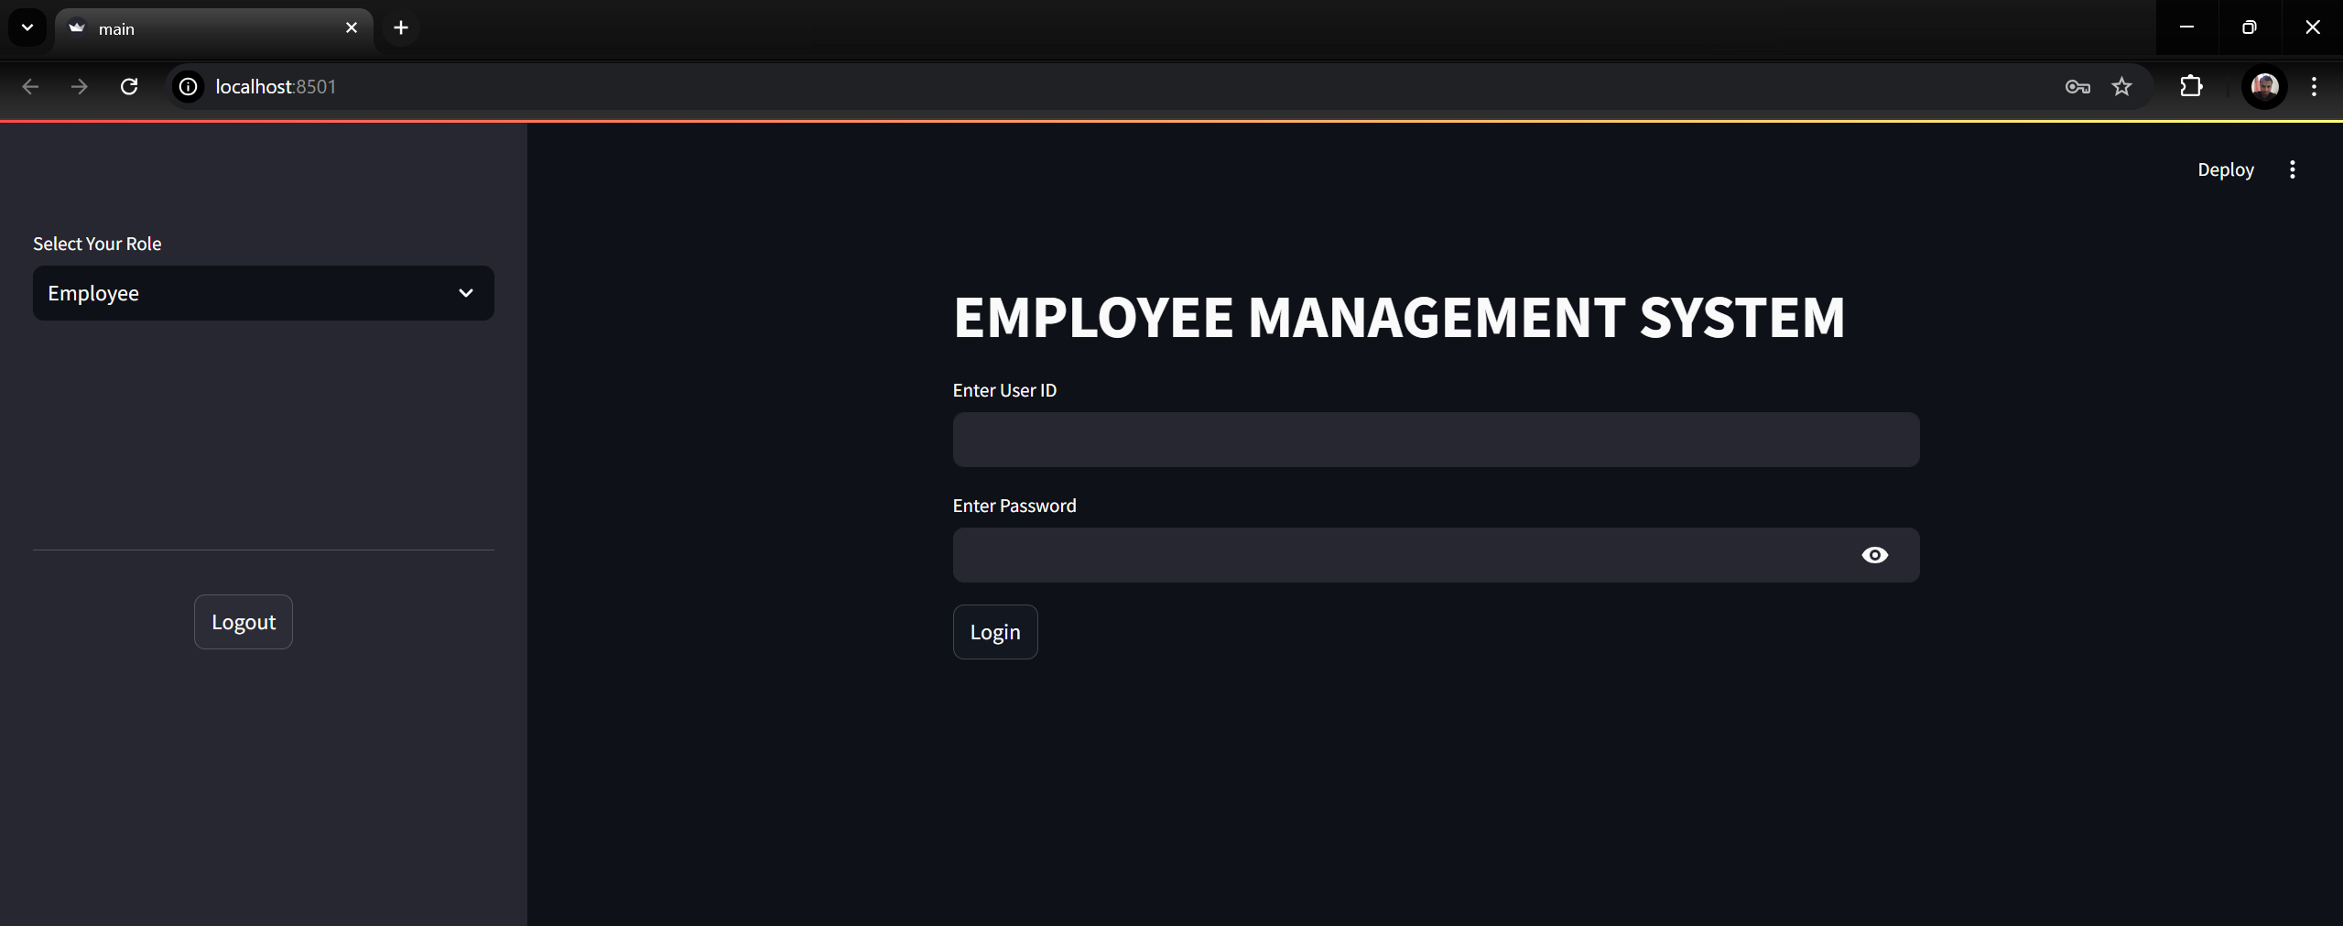

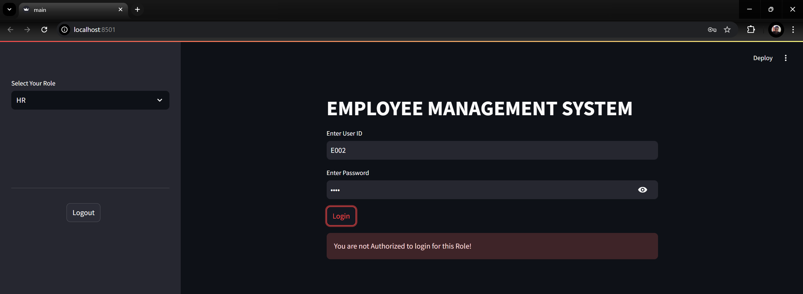

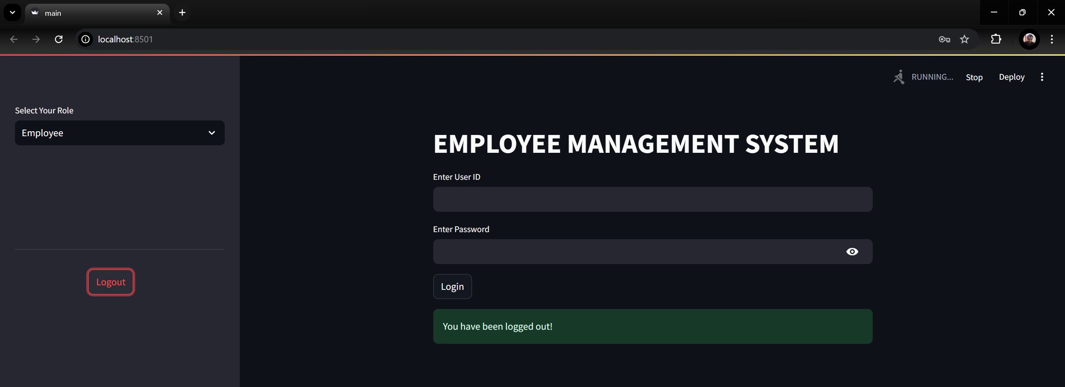

* 1. Employee screen:

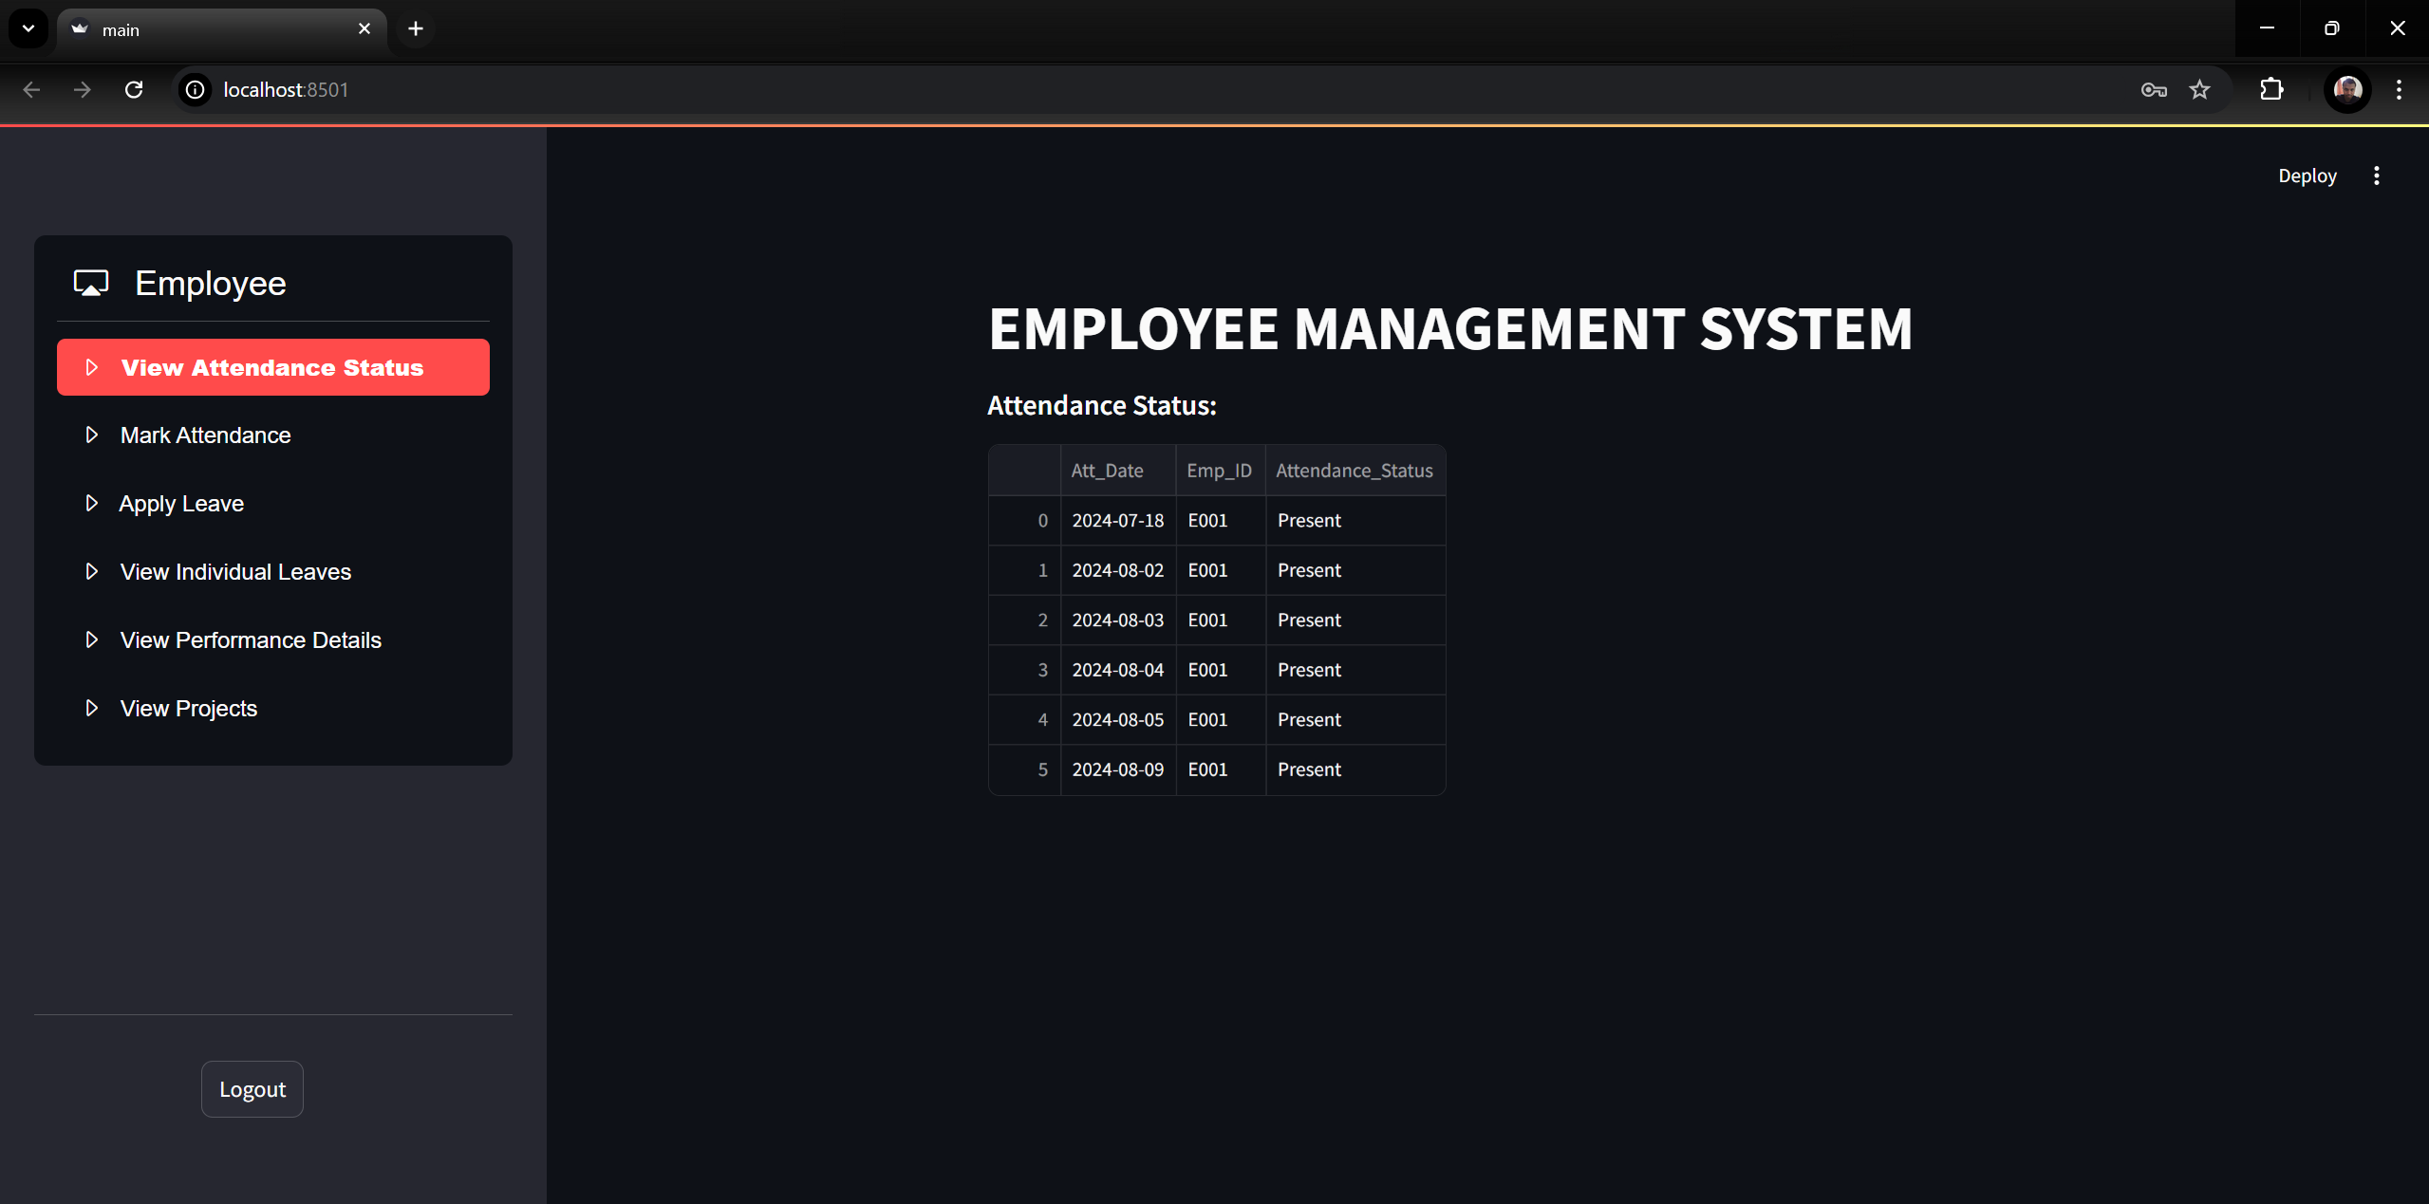

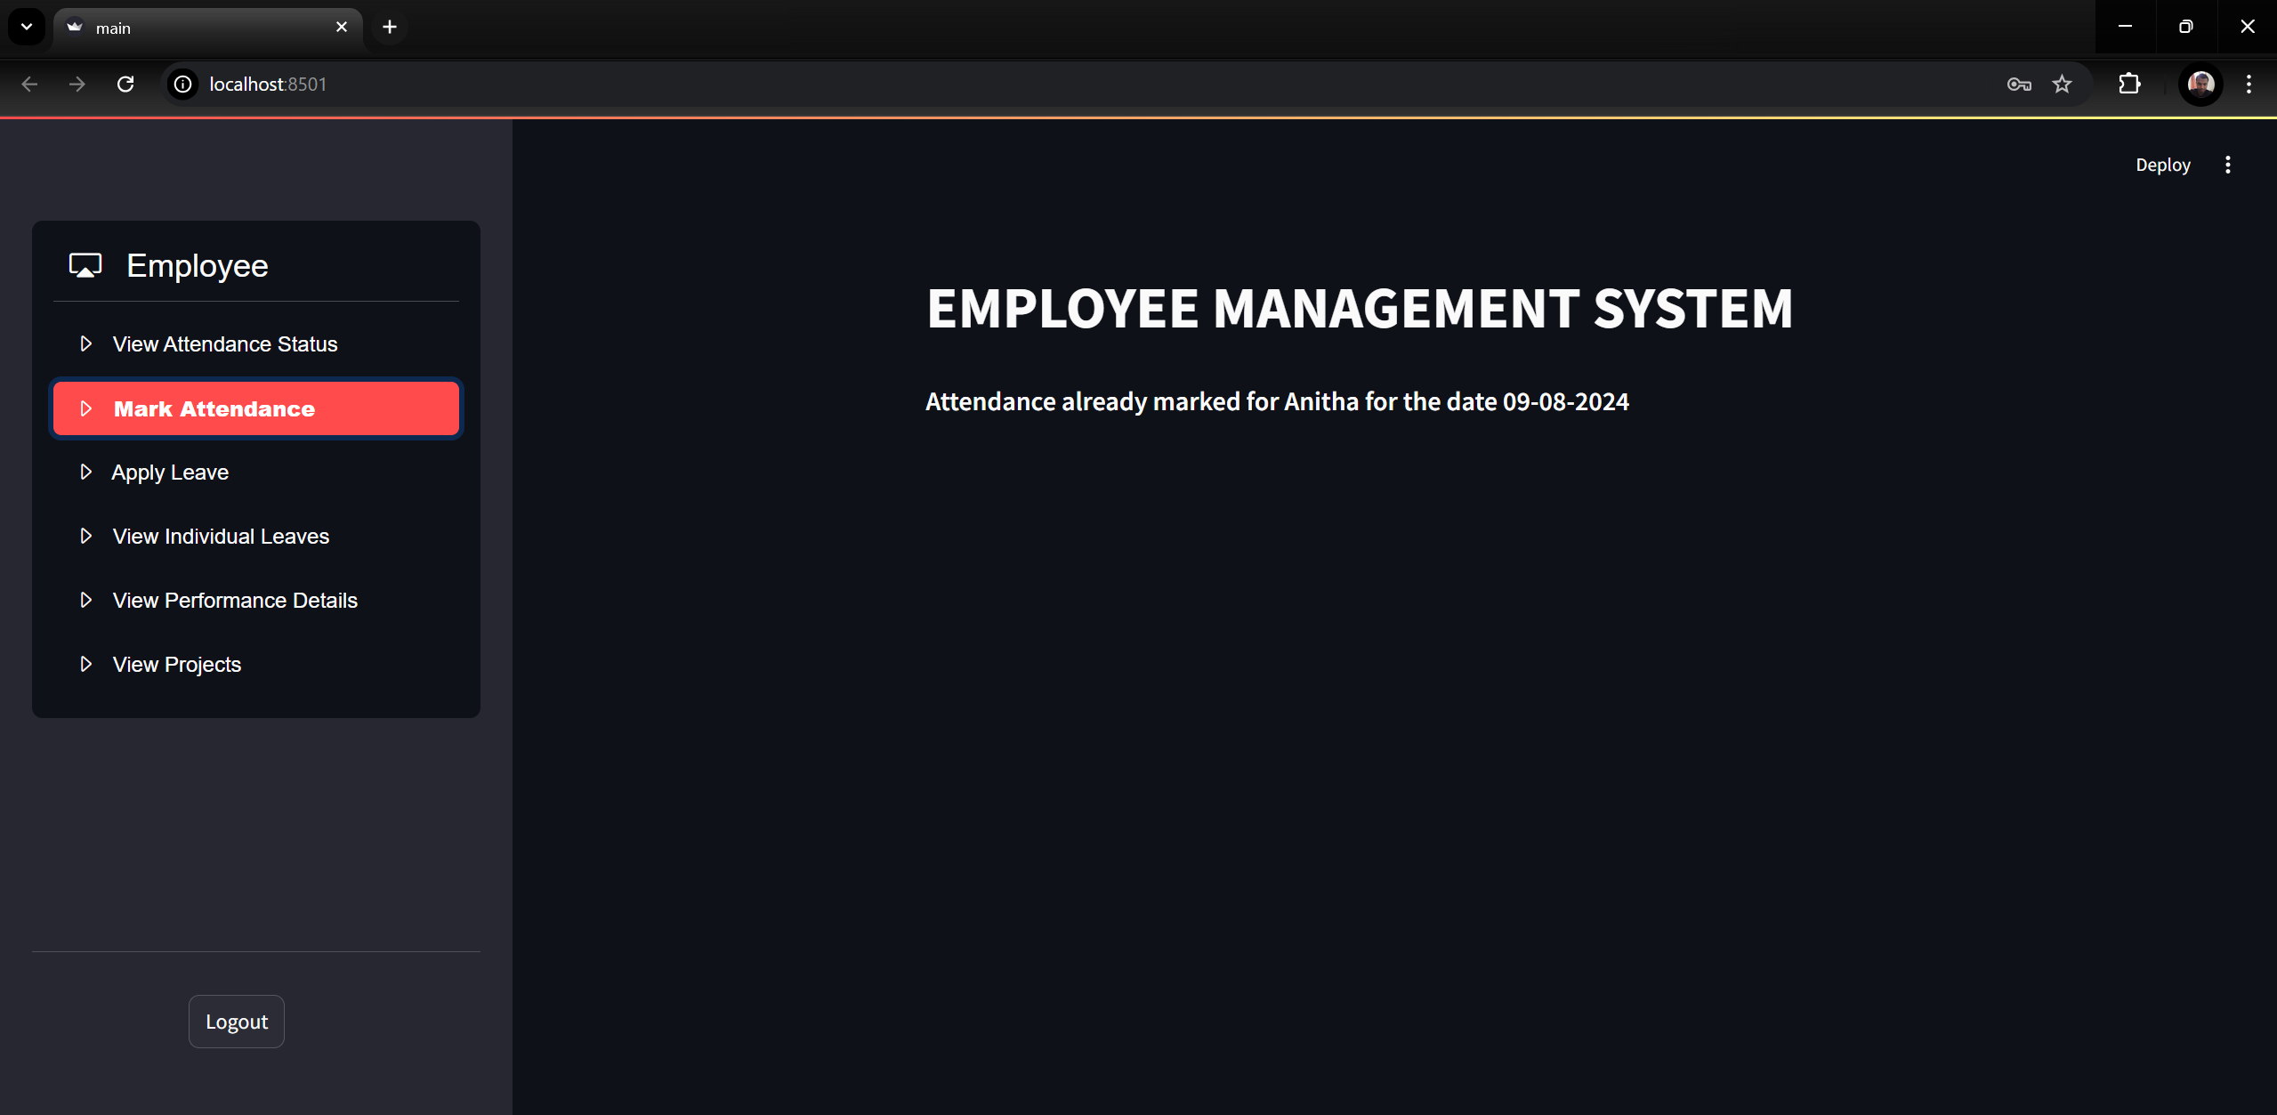

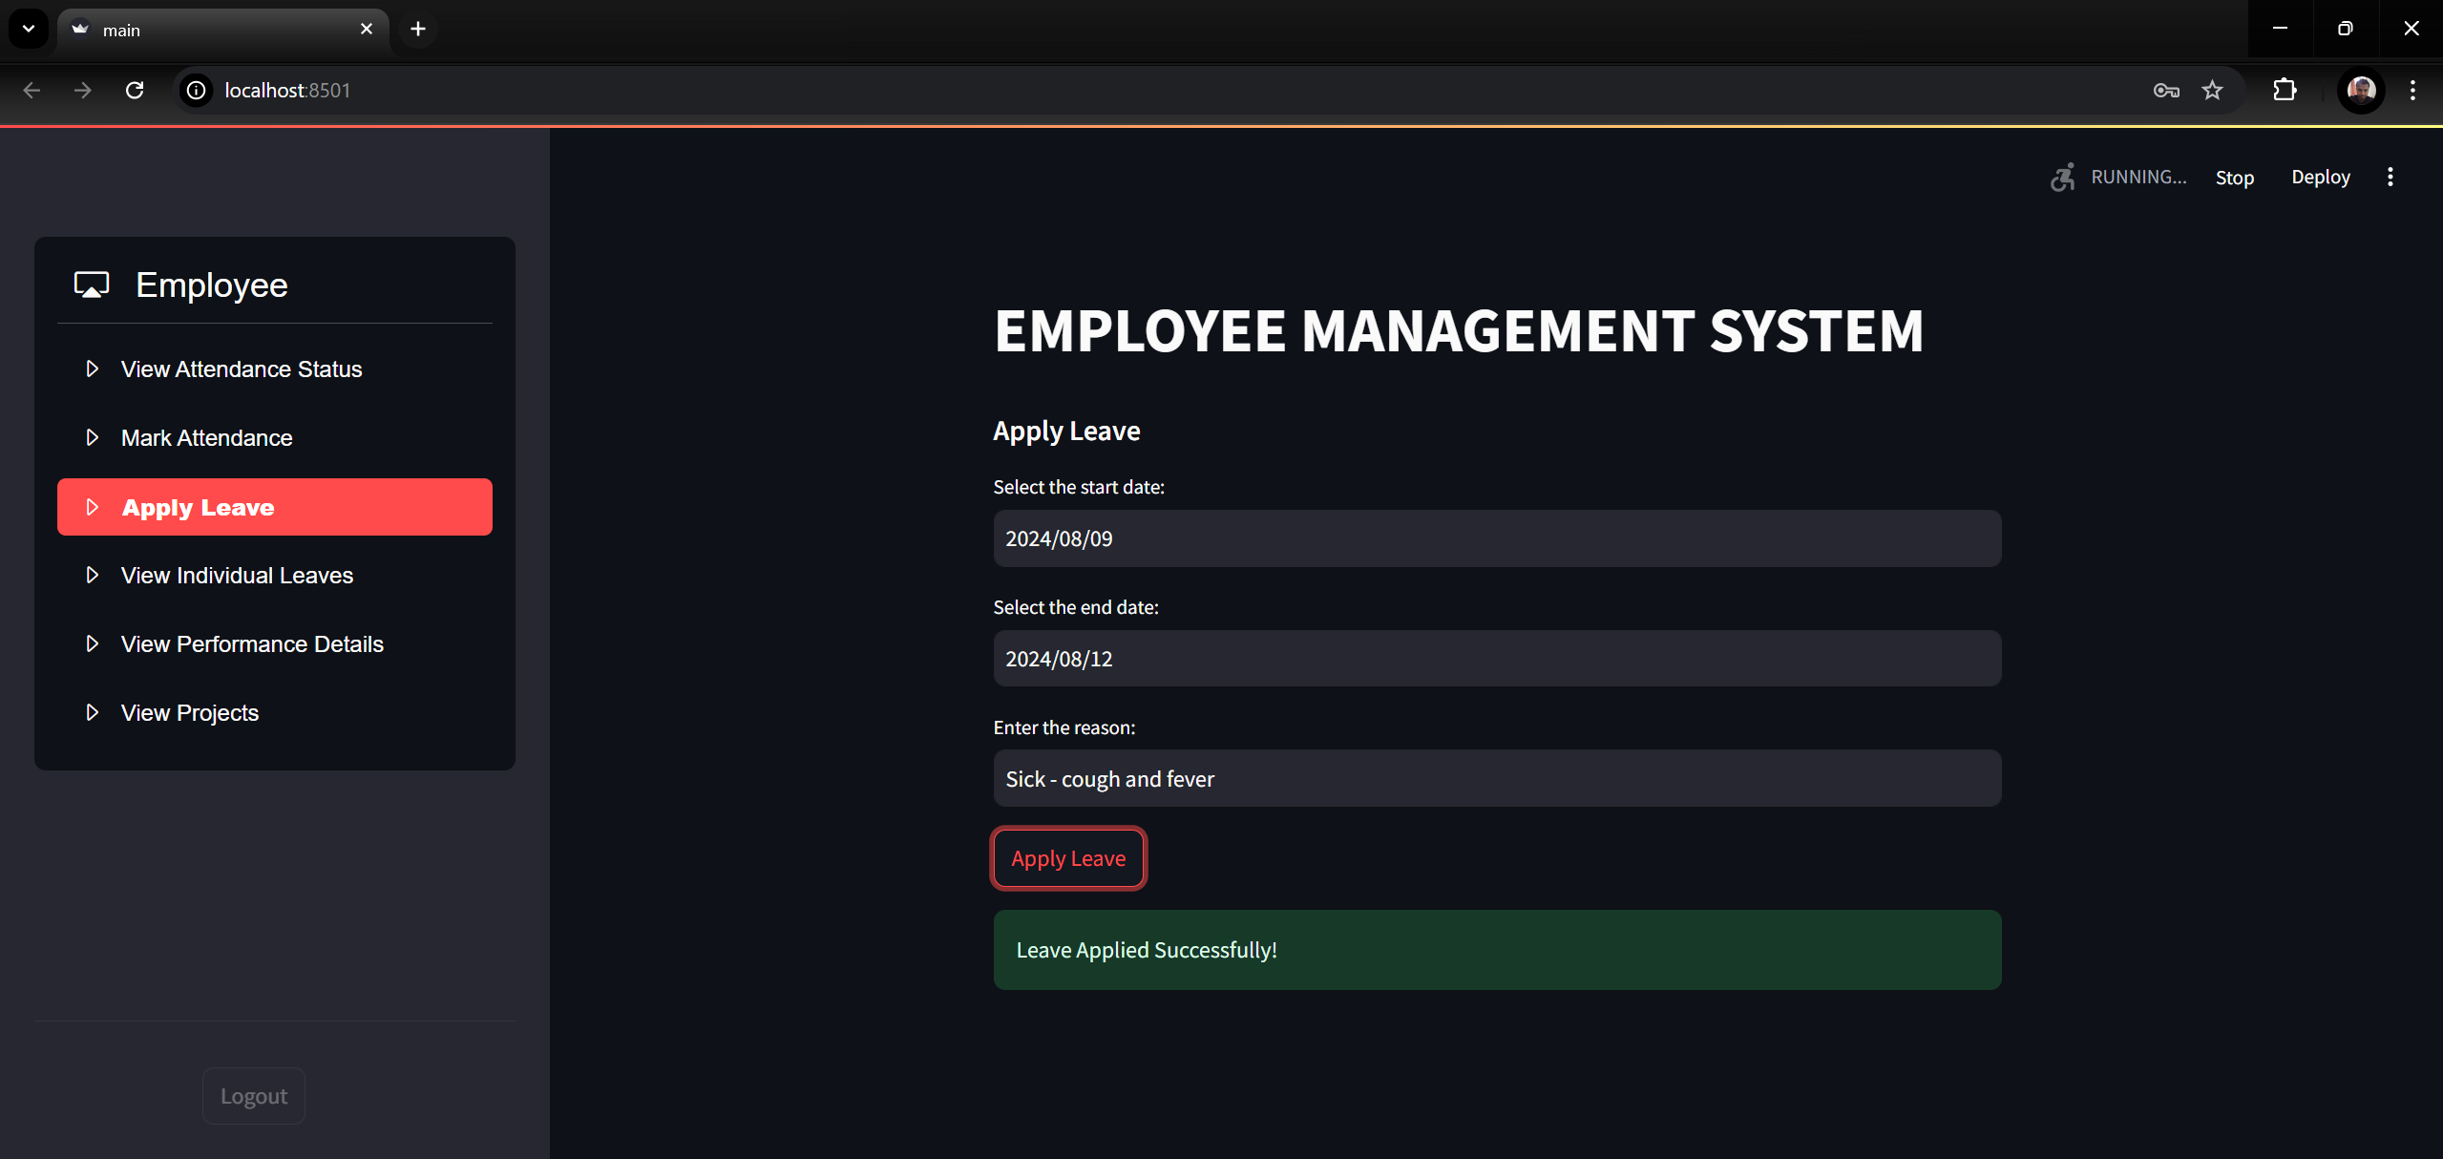

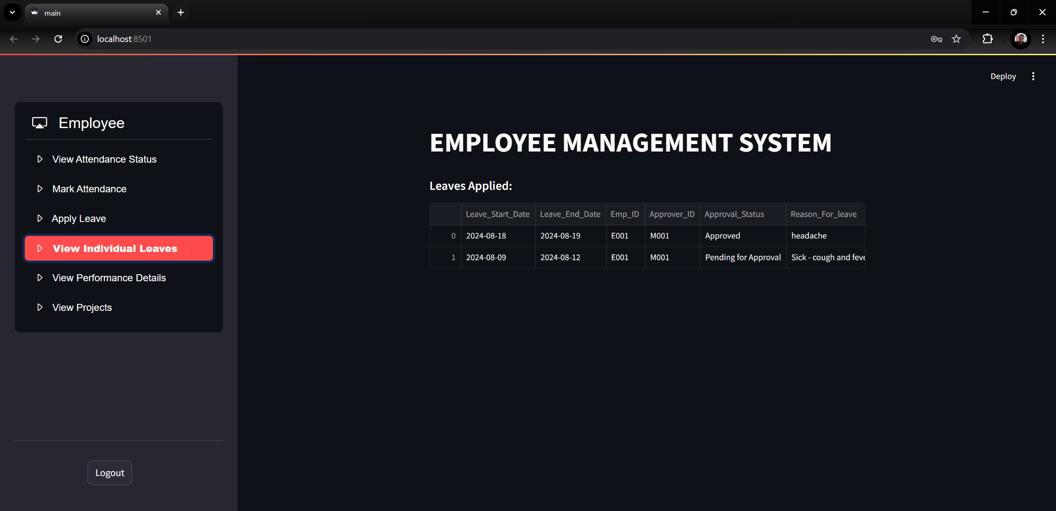

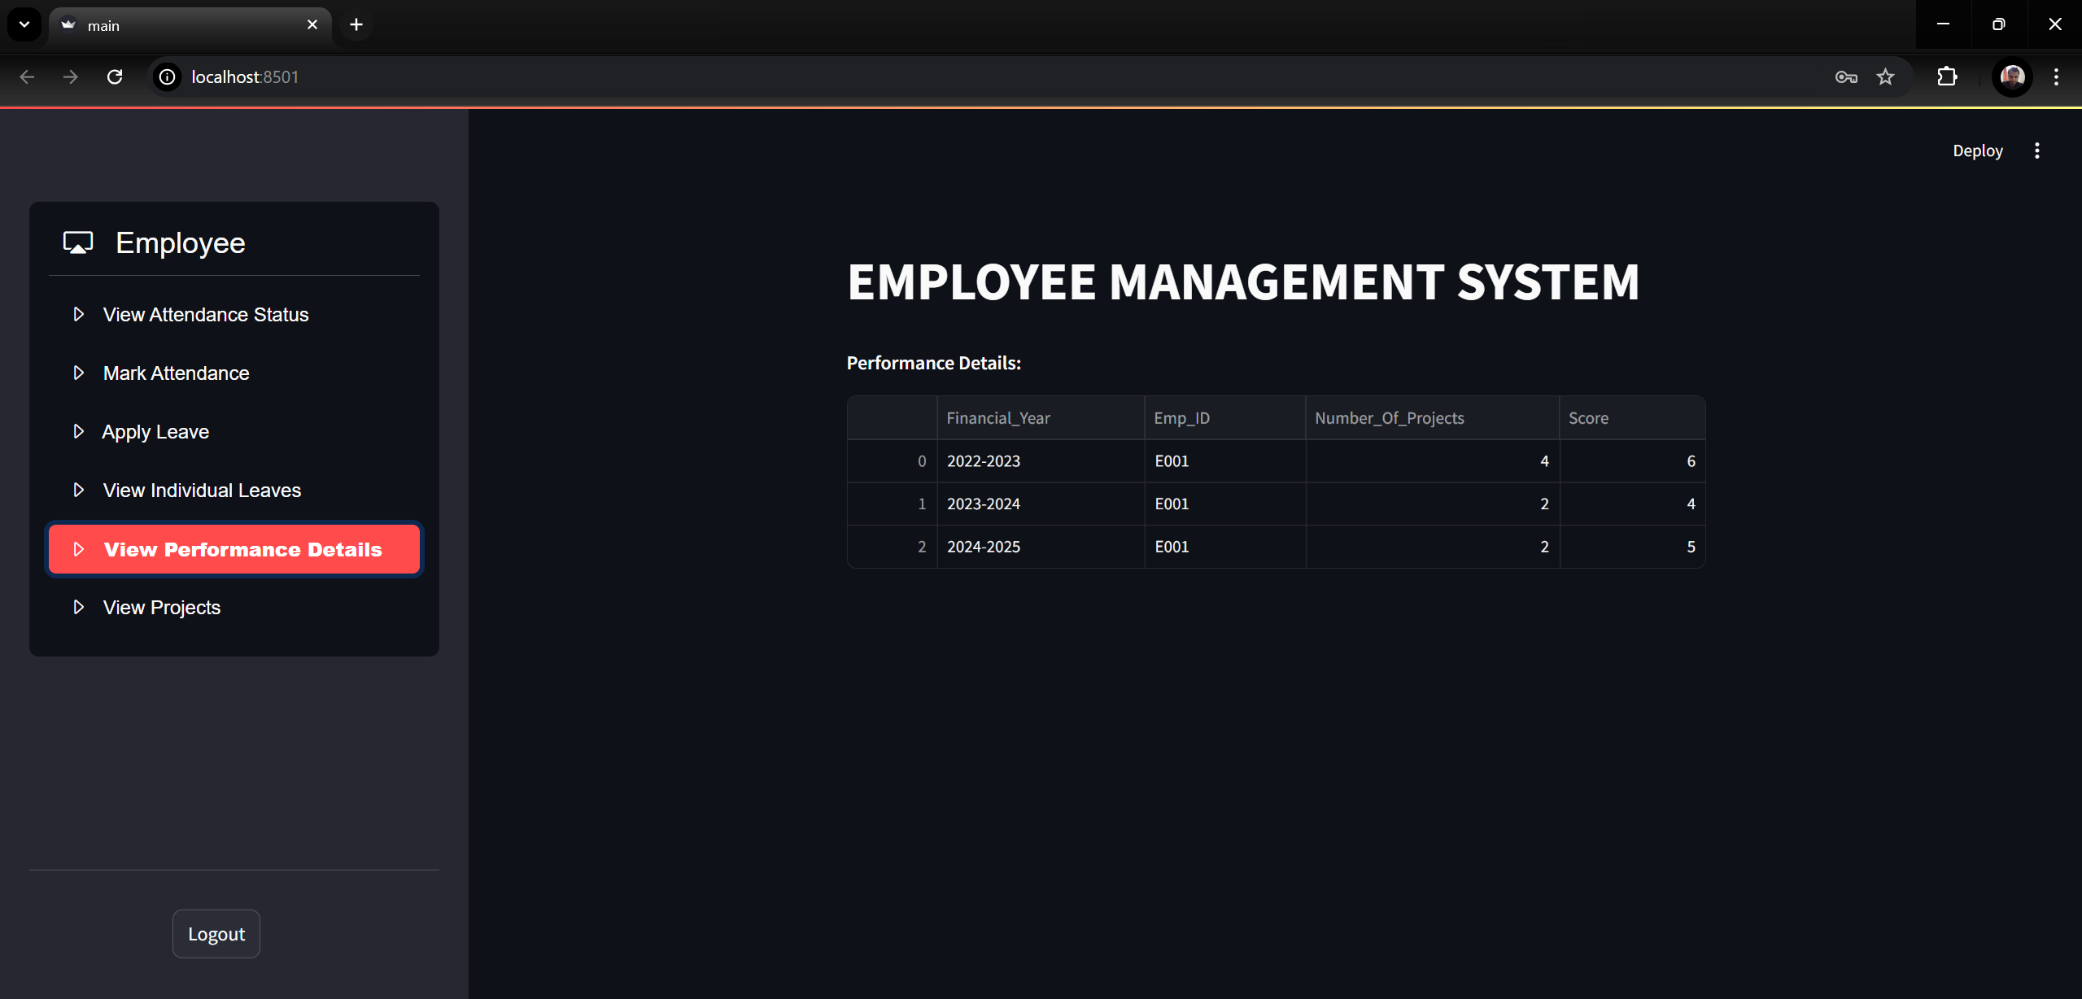

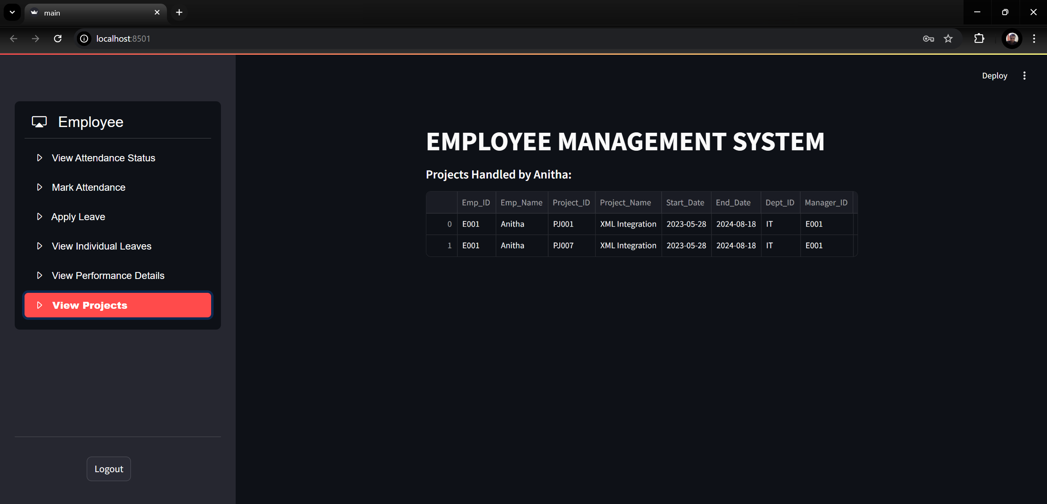

* 1. HR screen:

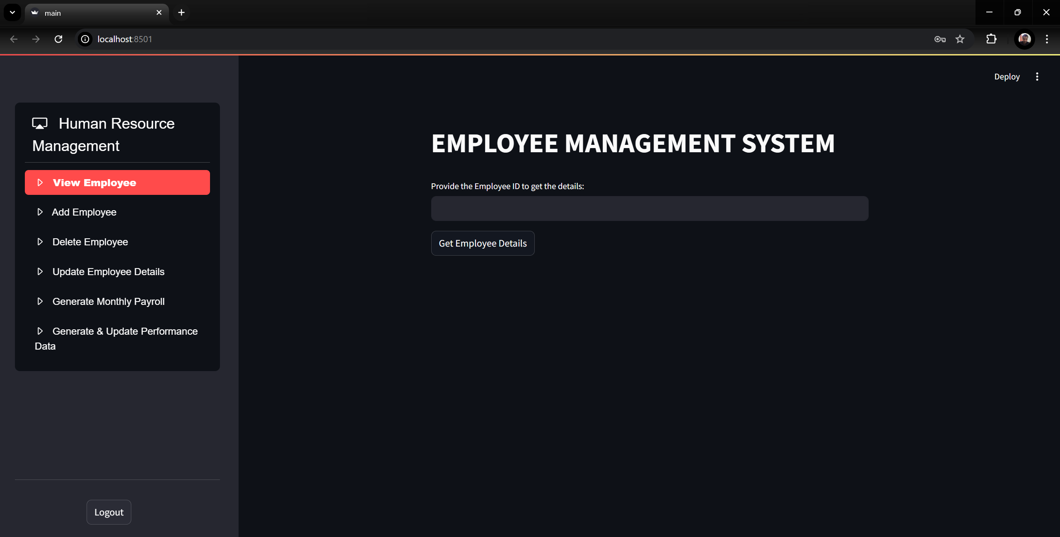

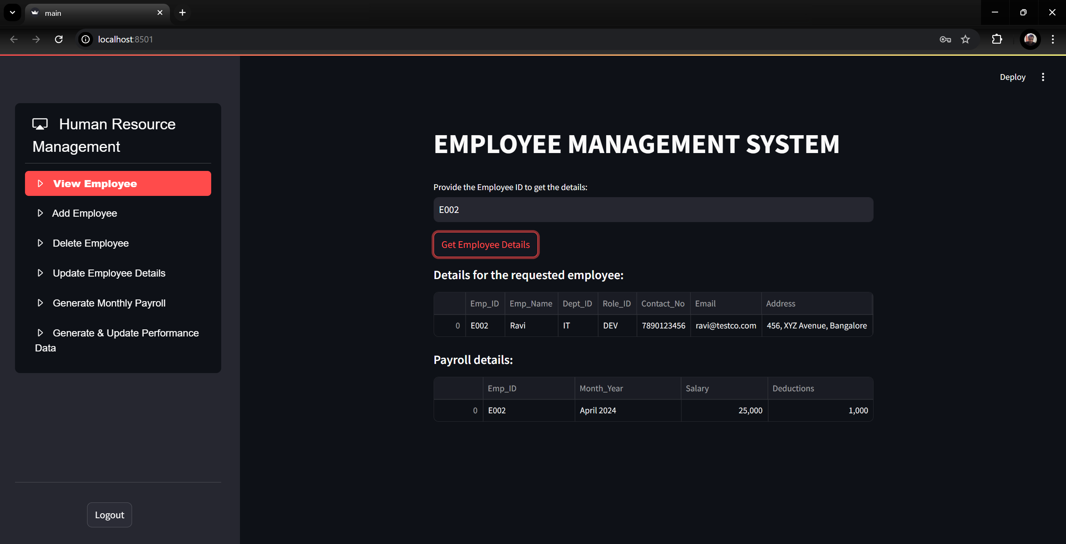

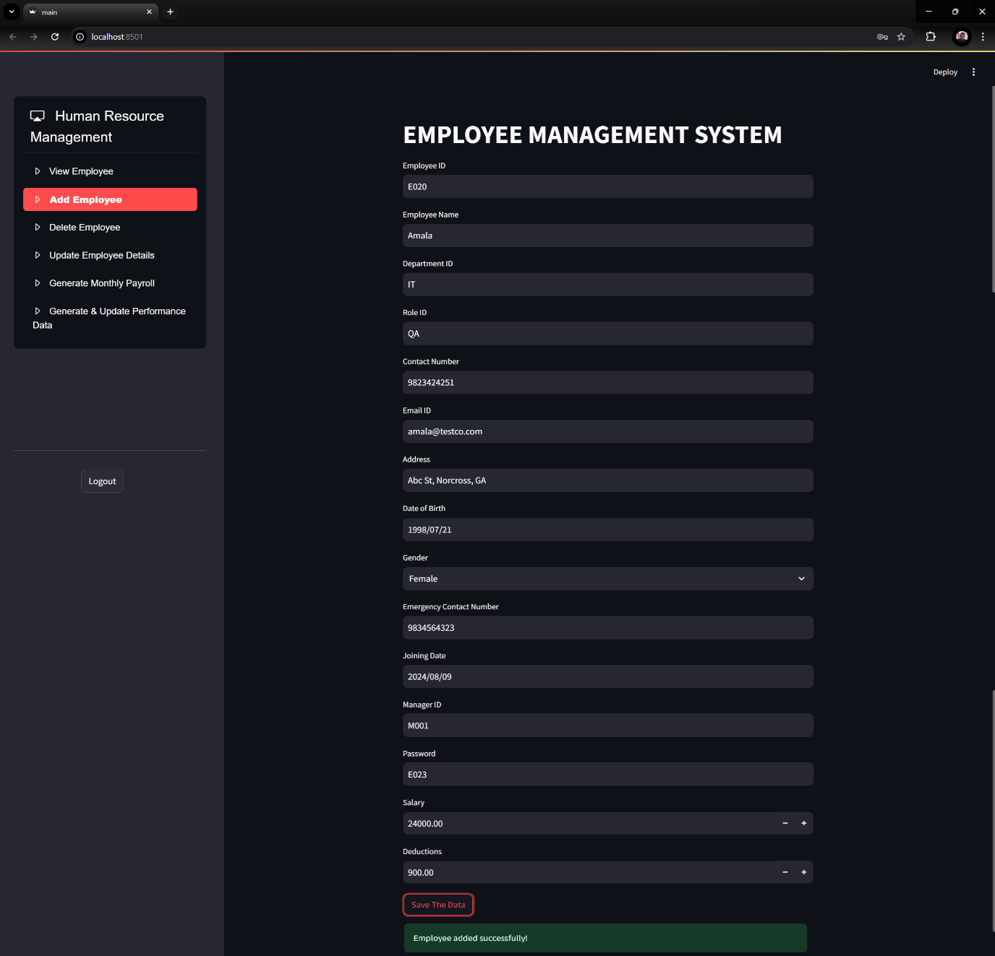

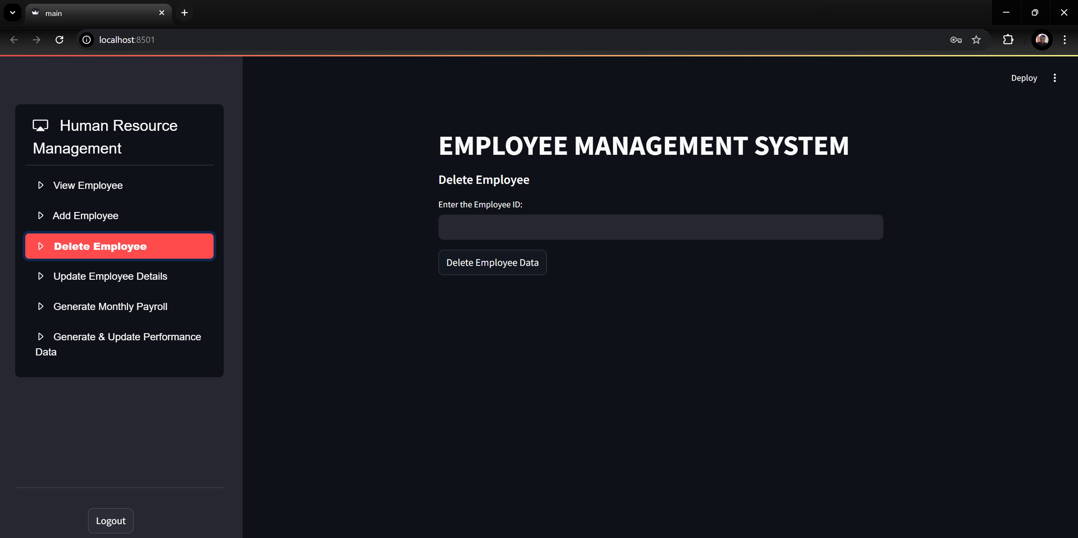

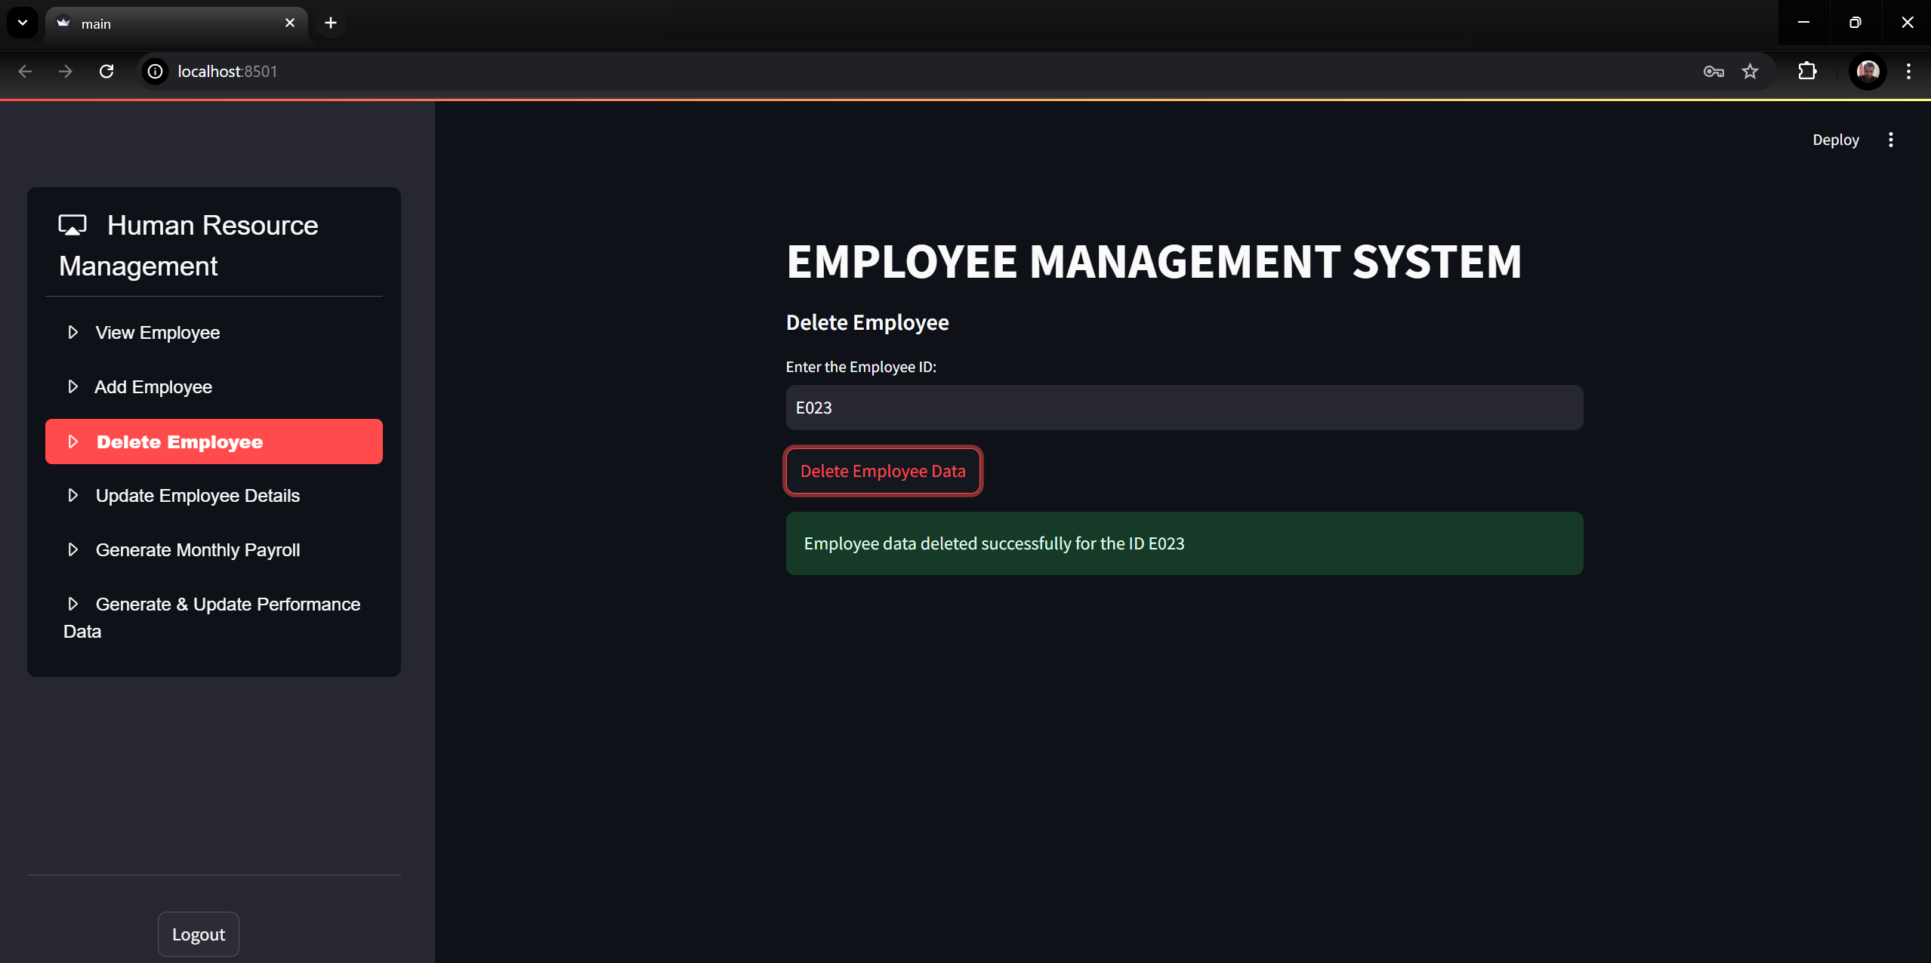

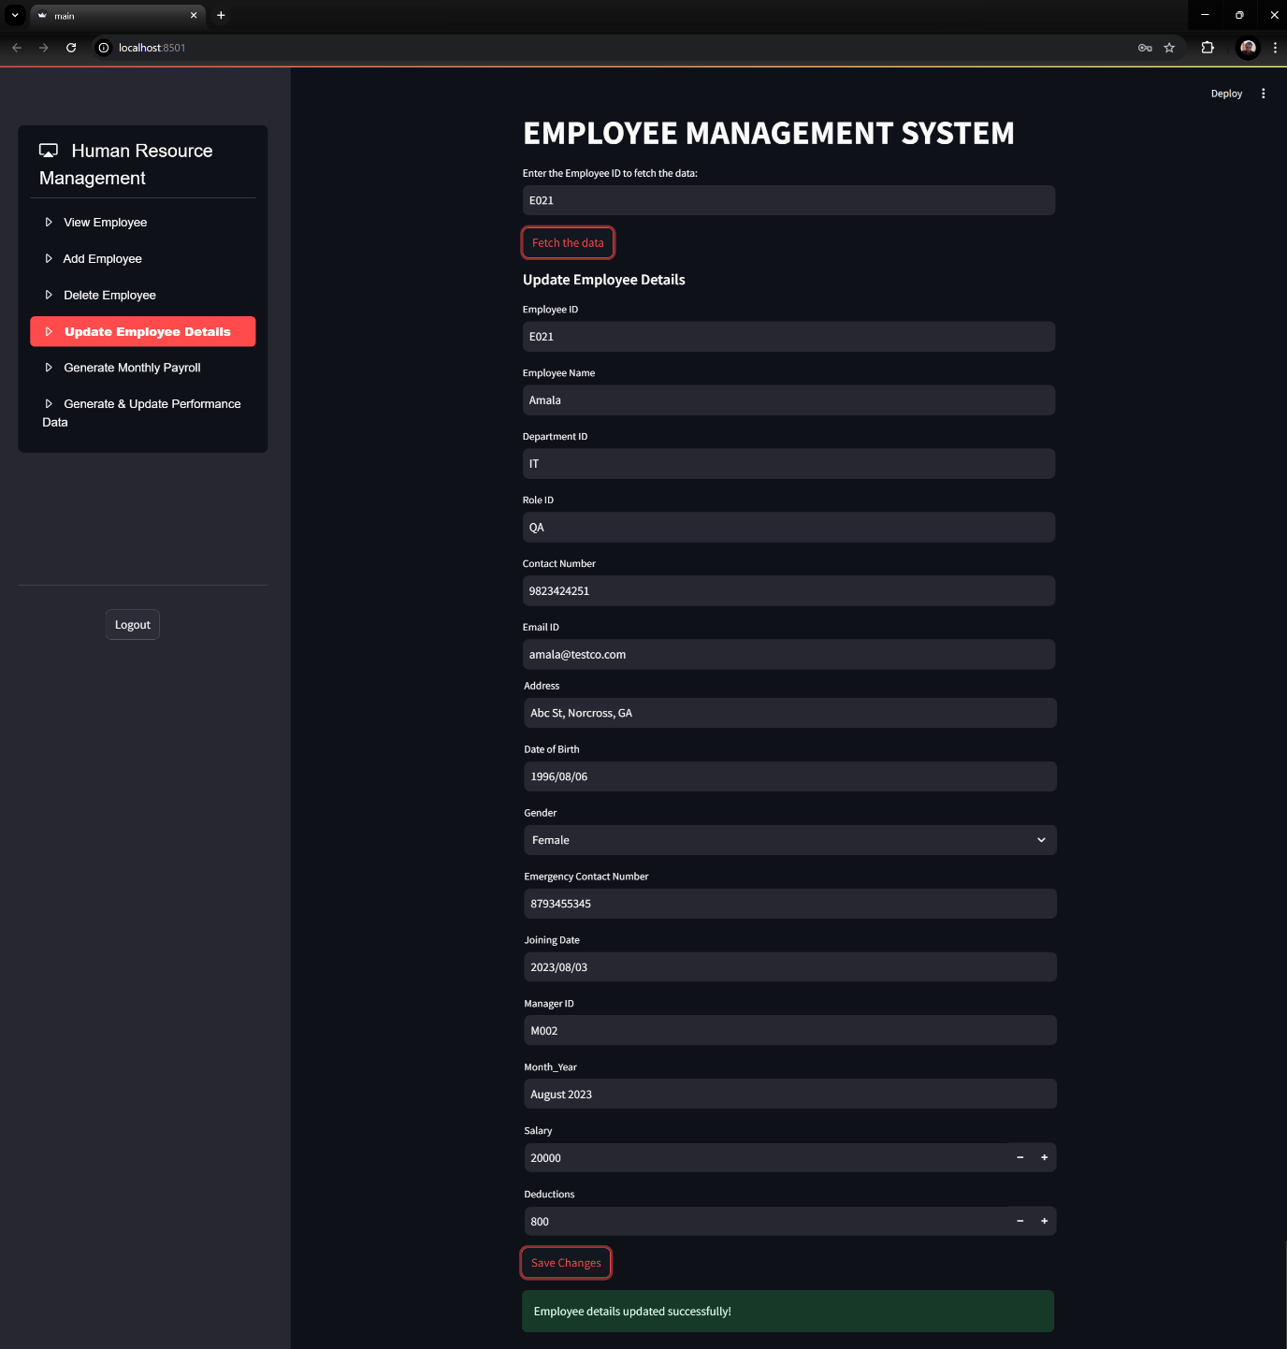

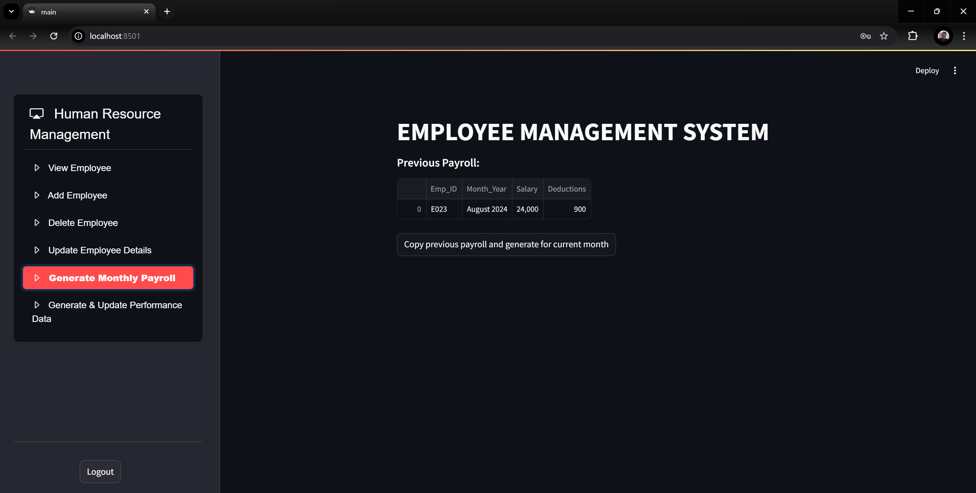

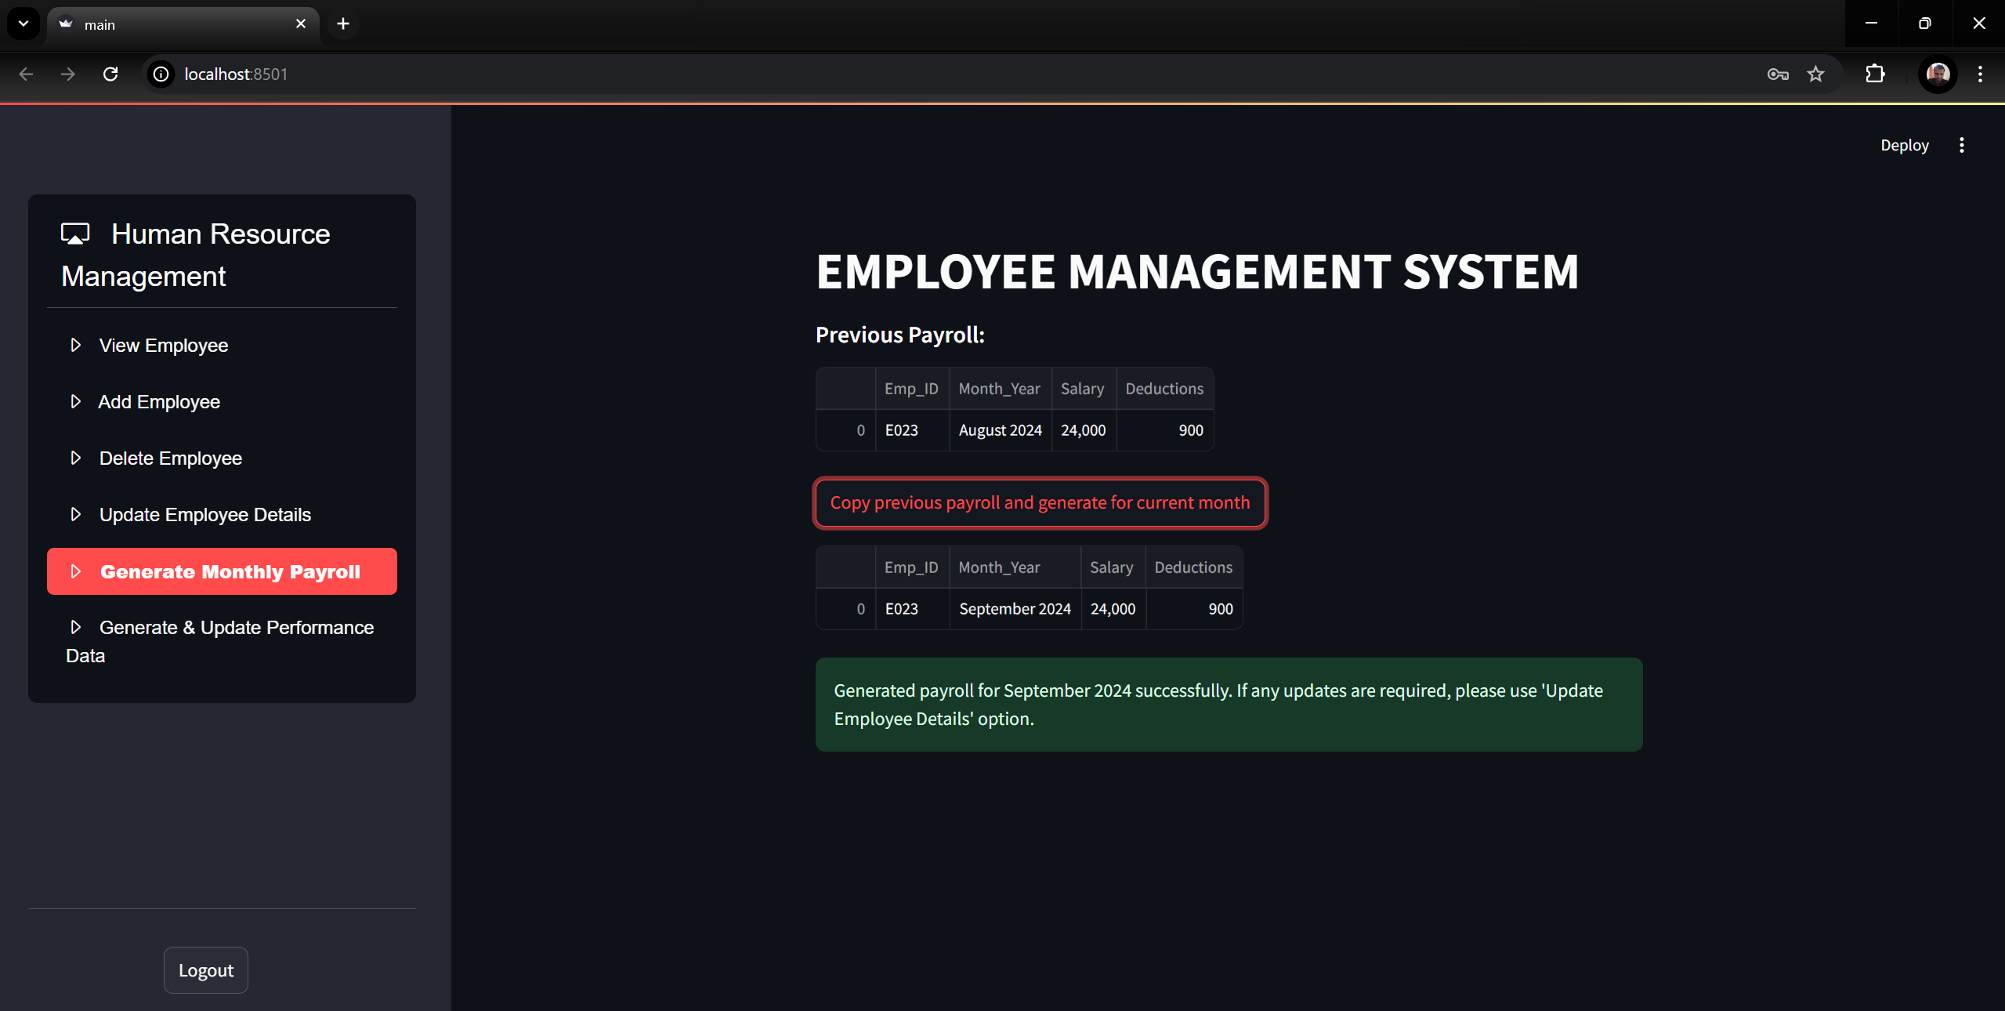

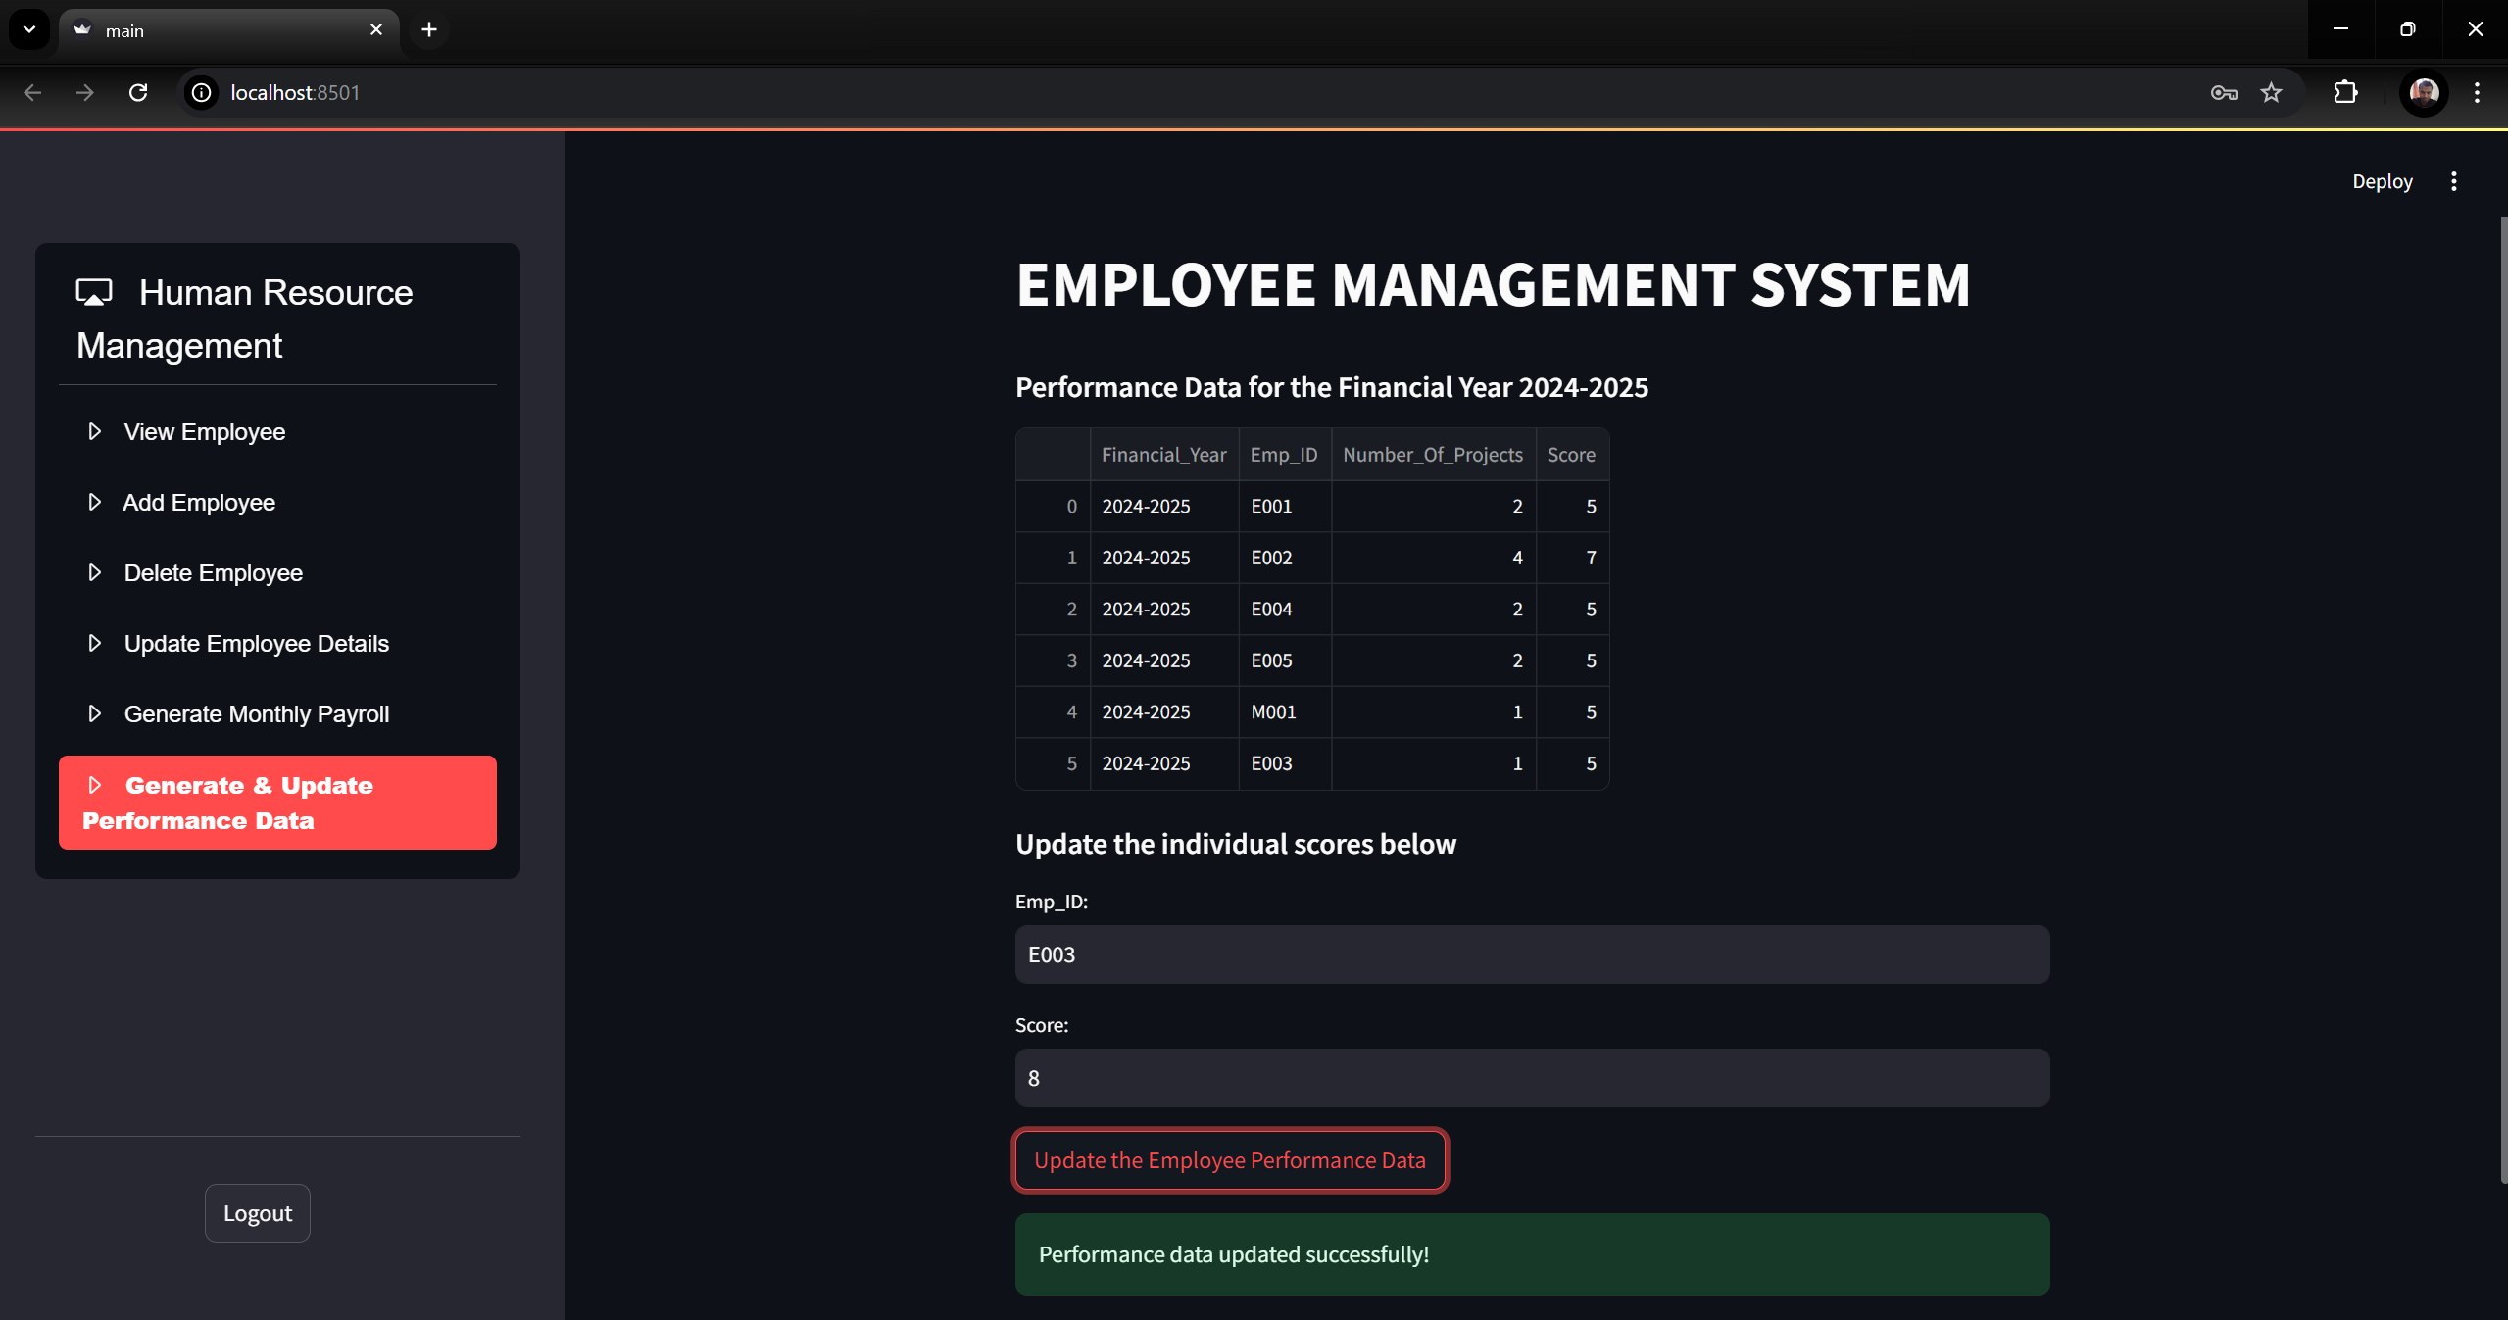

* 1. Department Head screen:

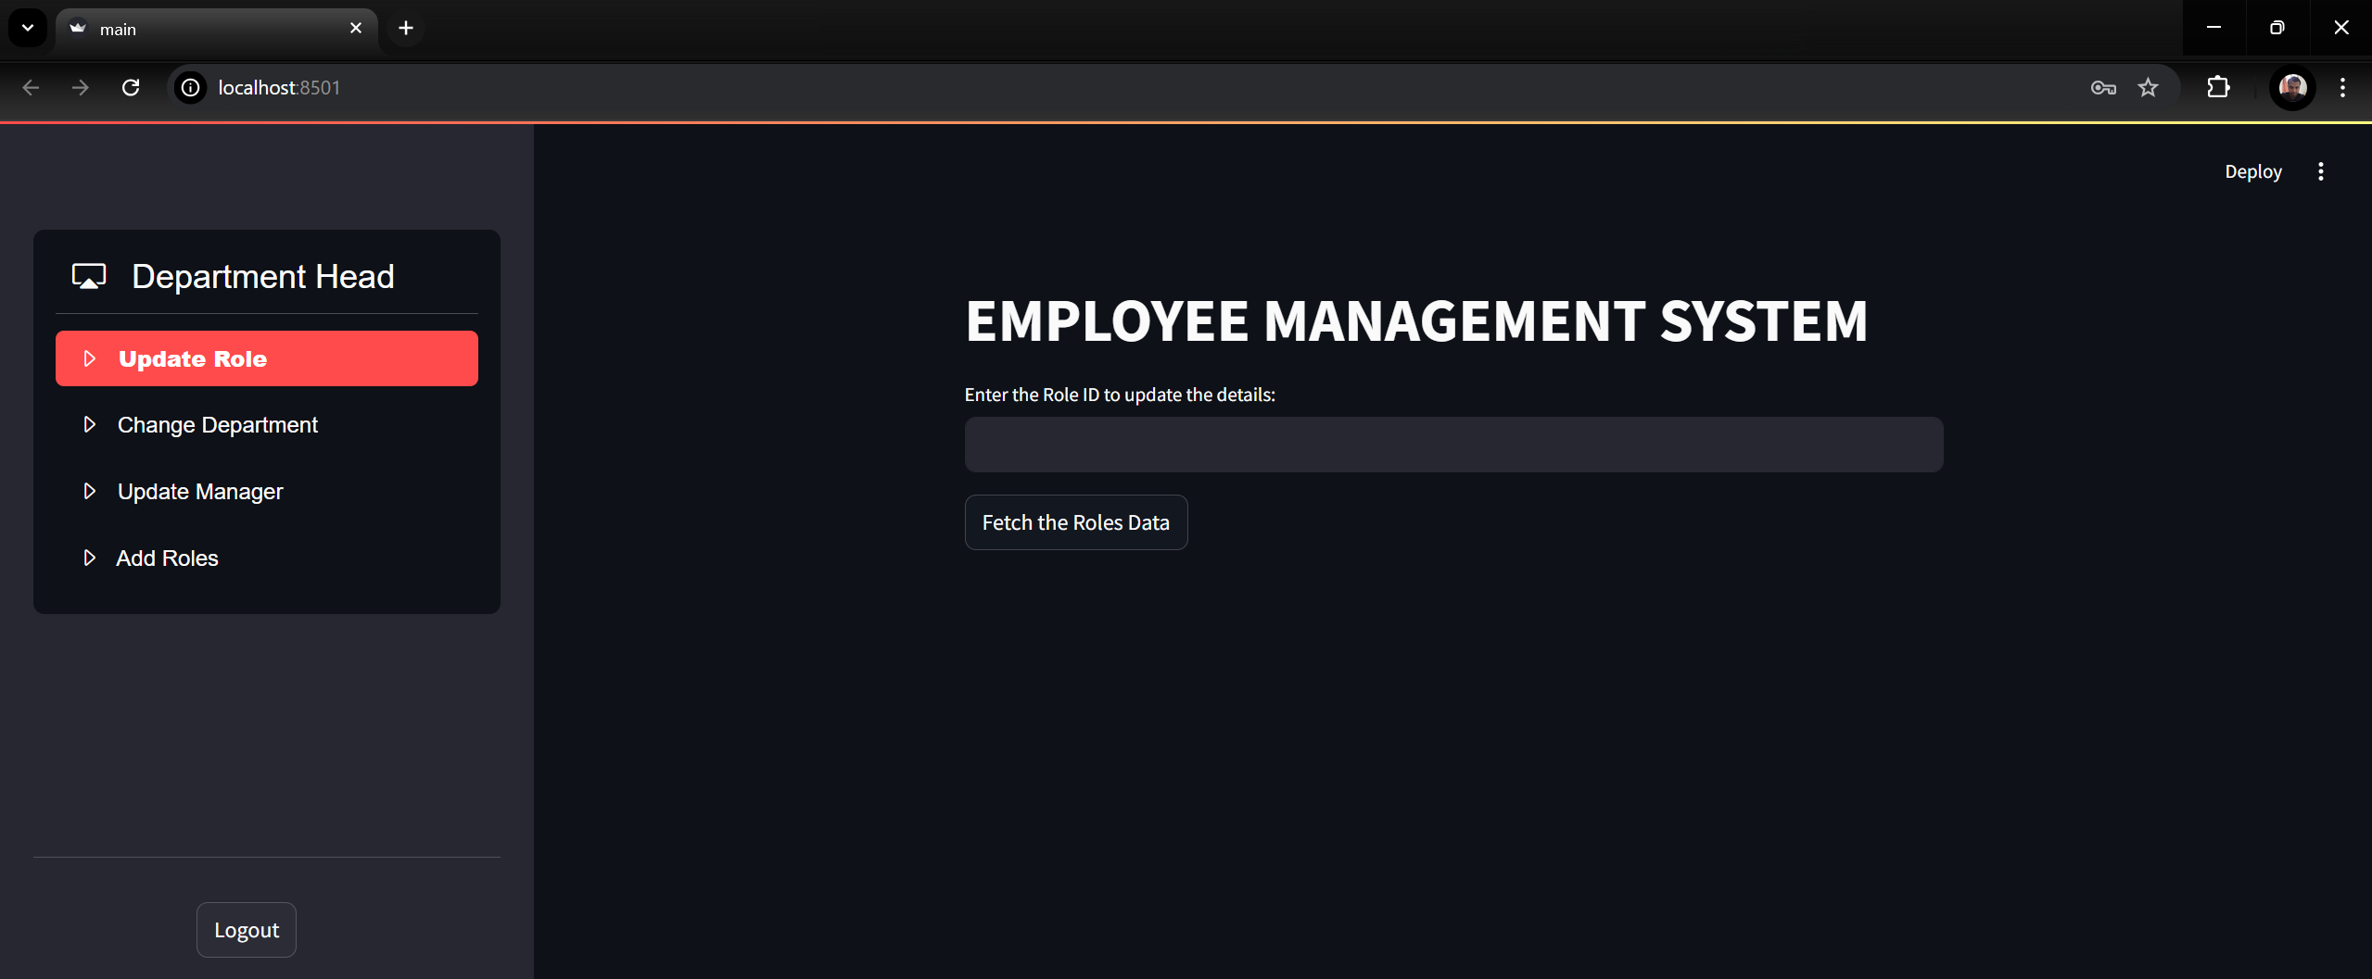

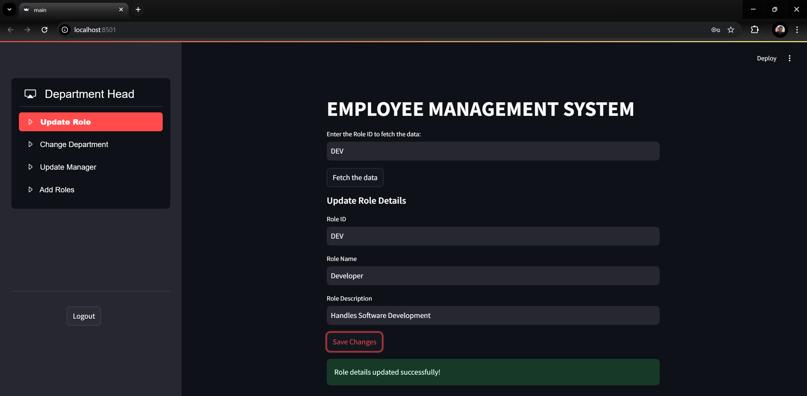

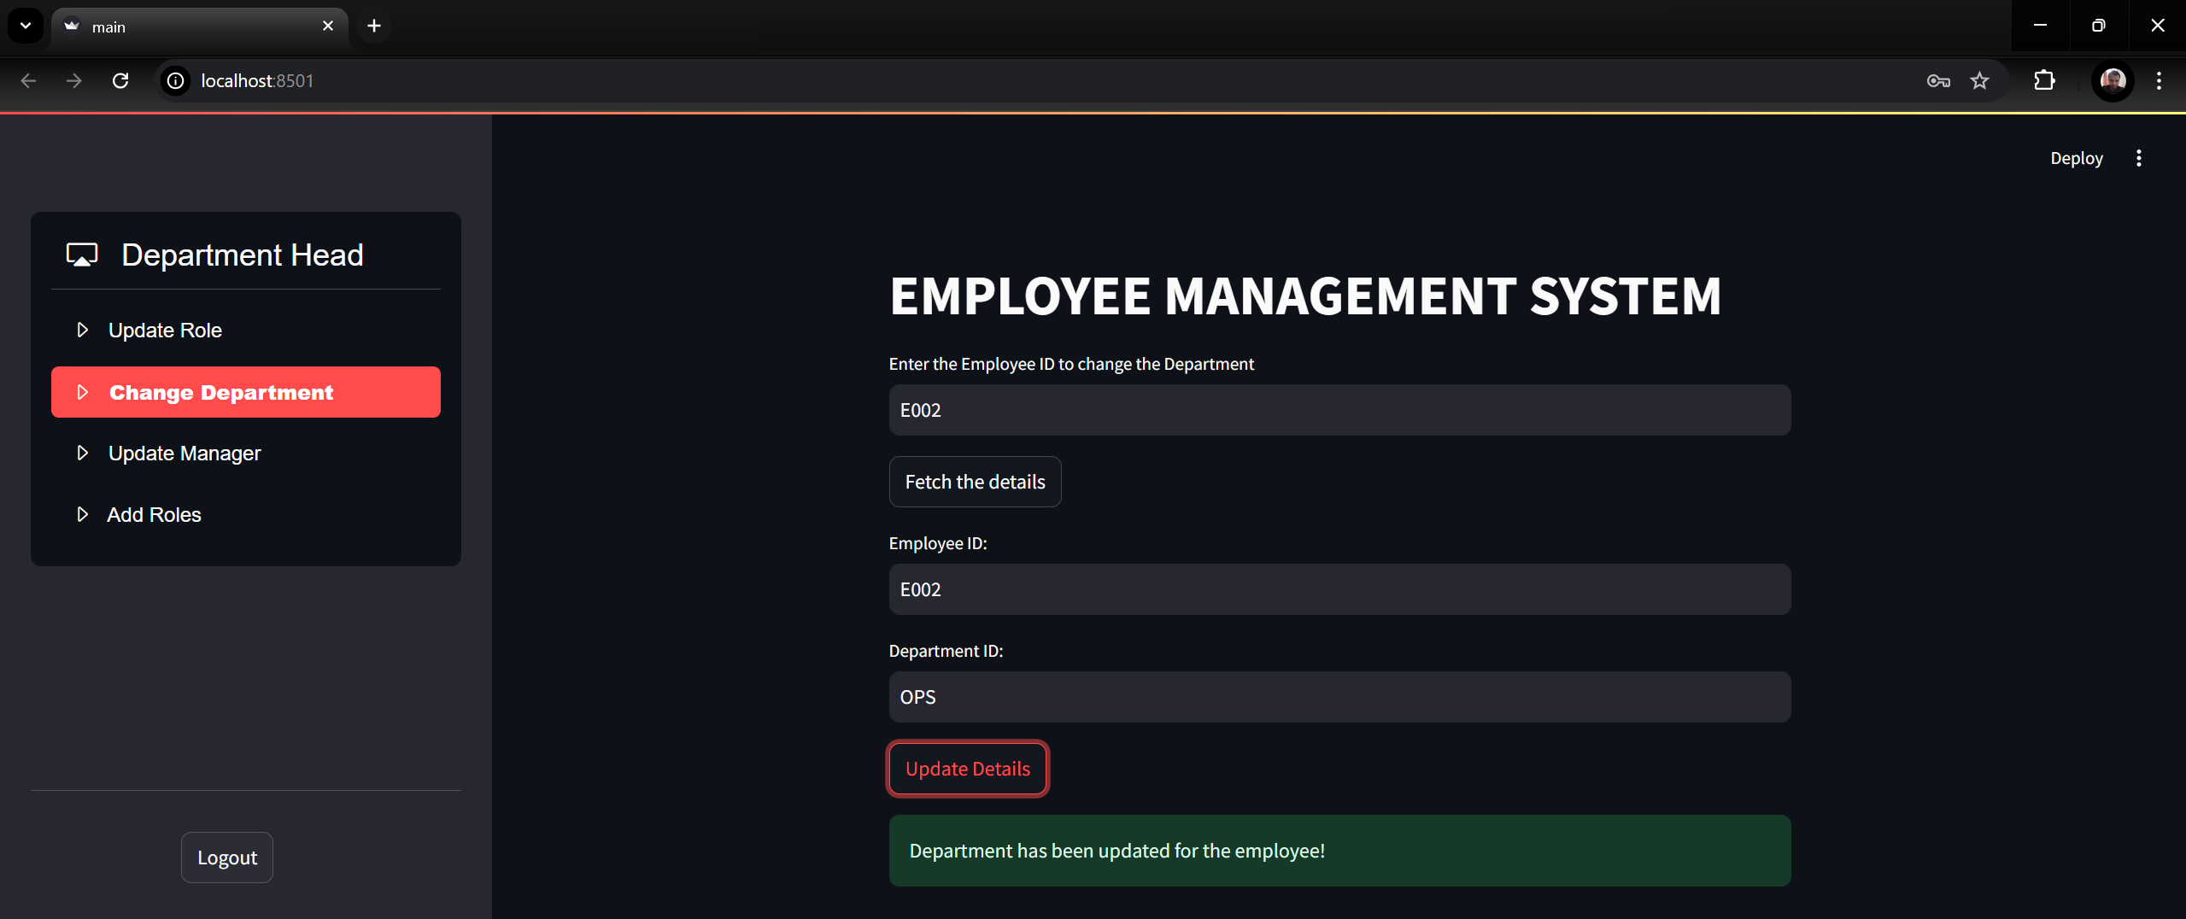

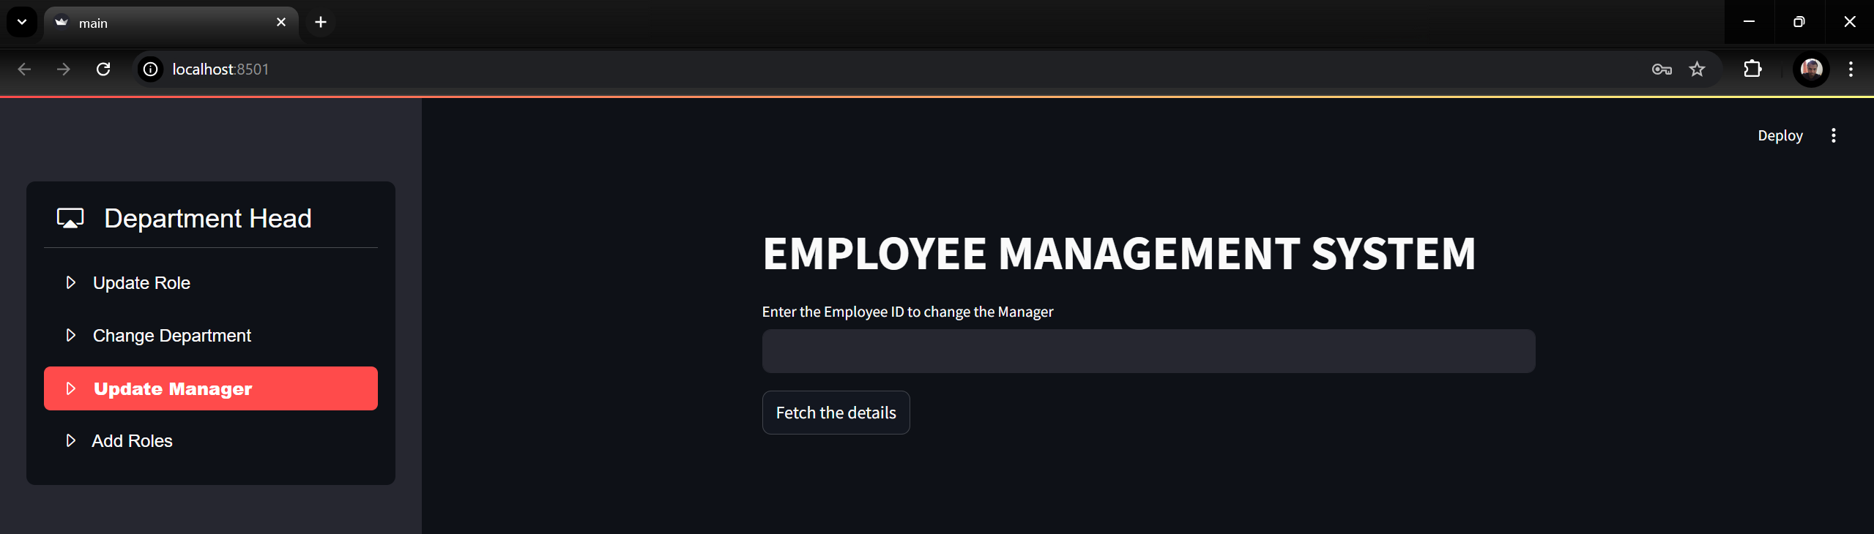

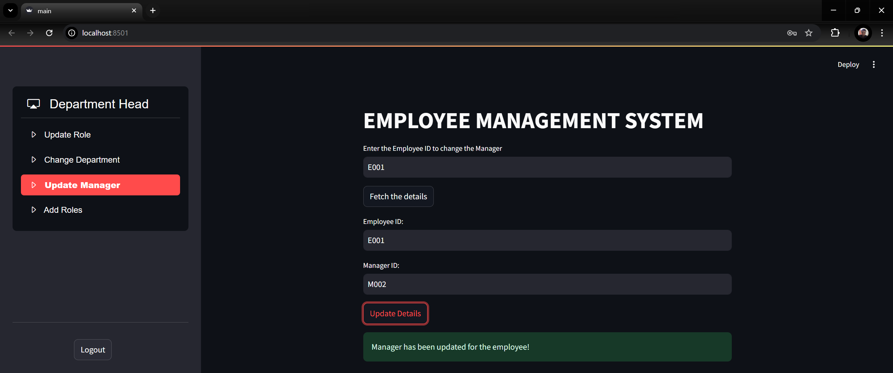

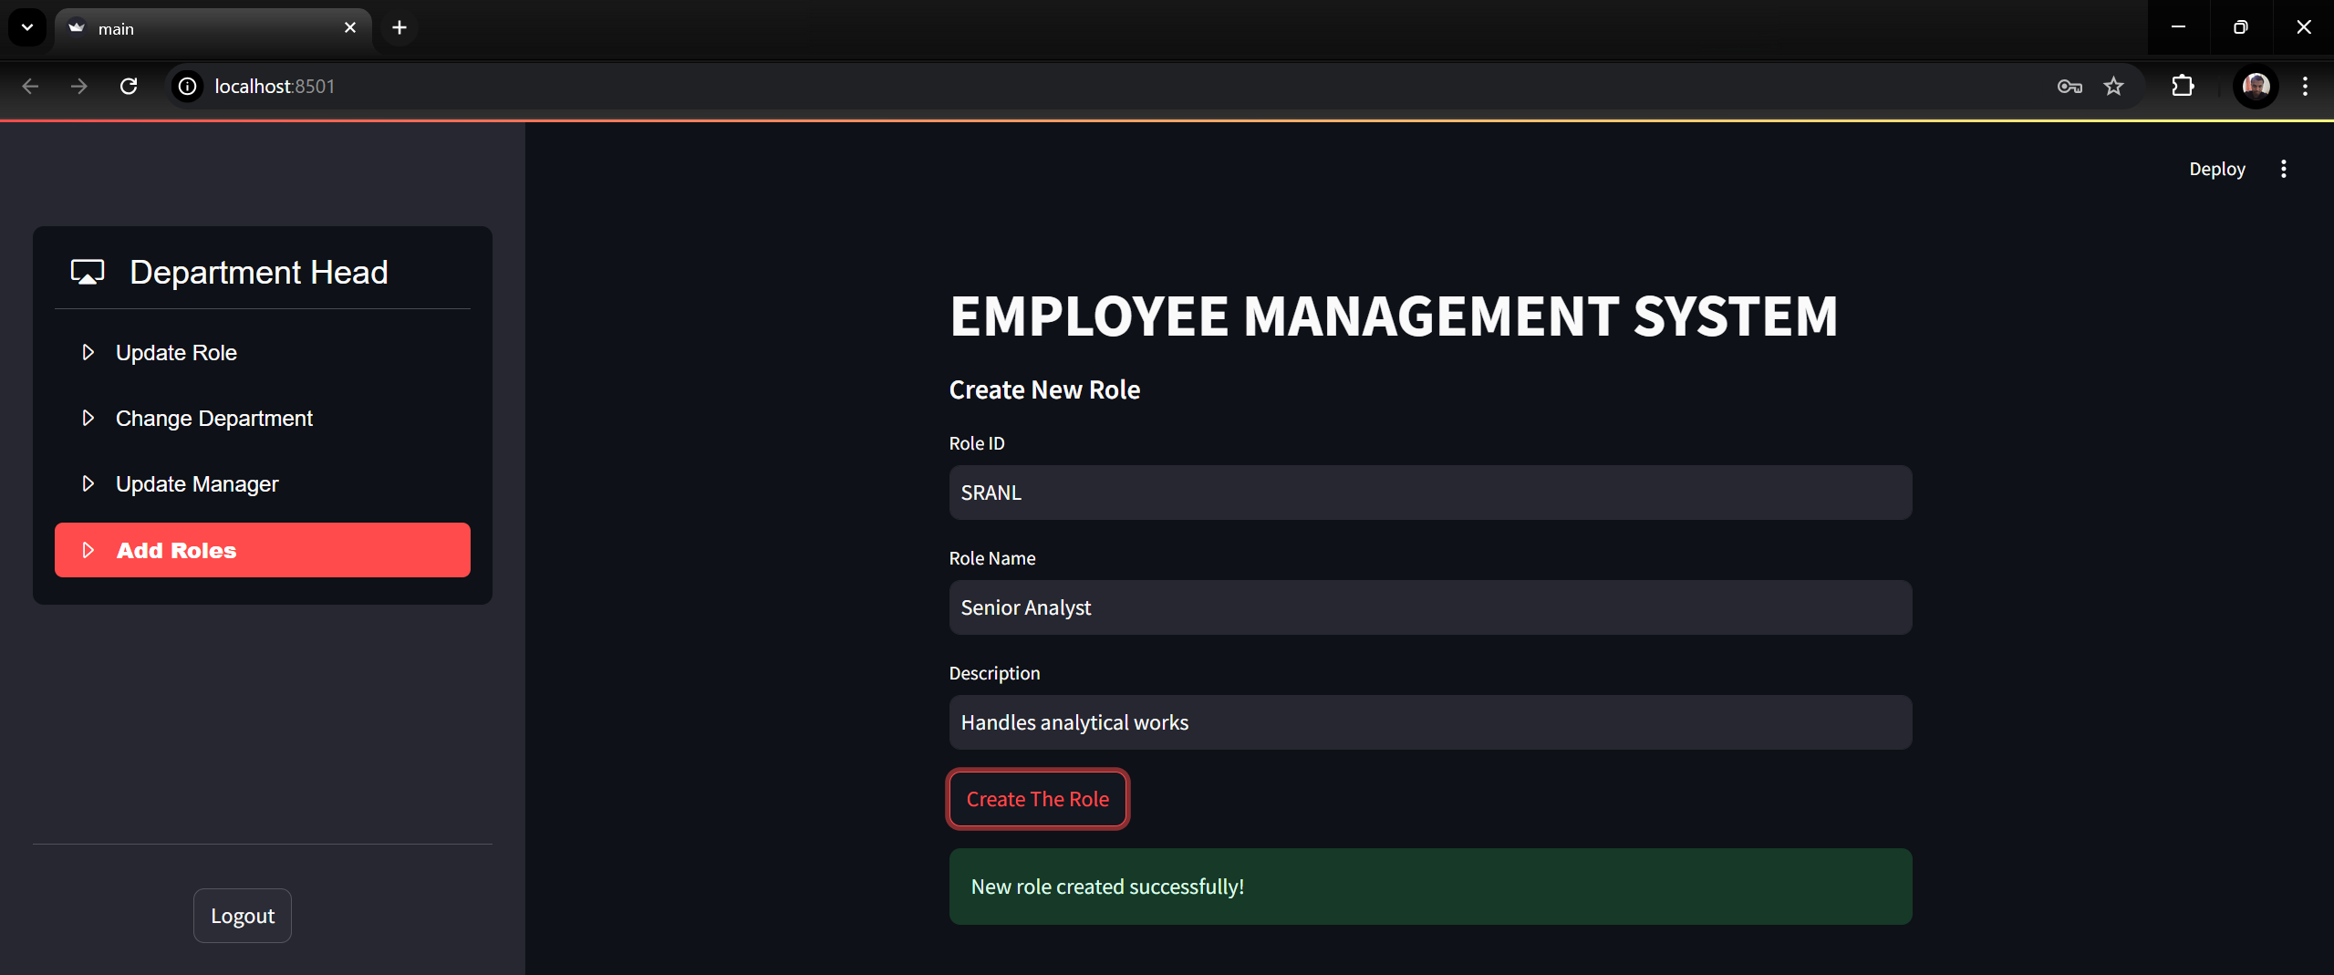

* 1. Manager screen:

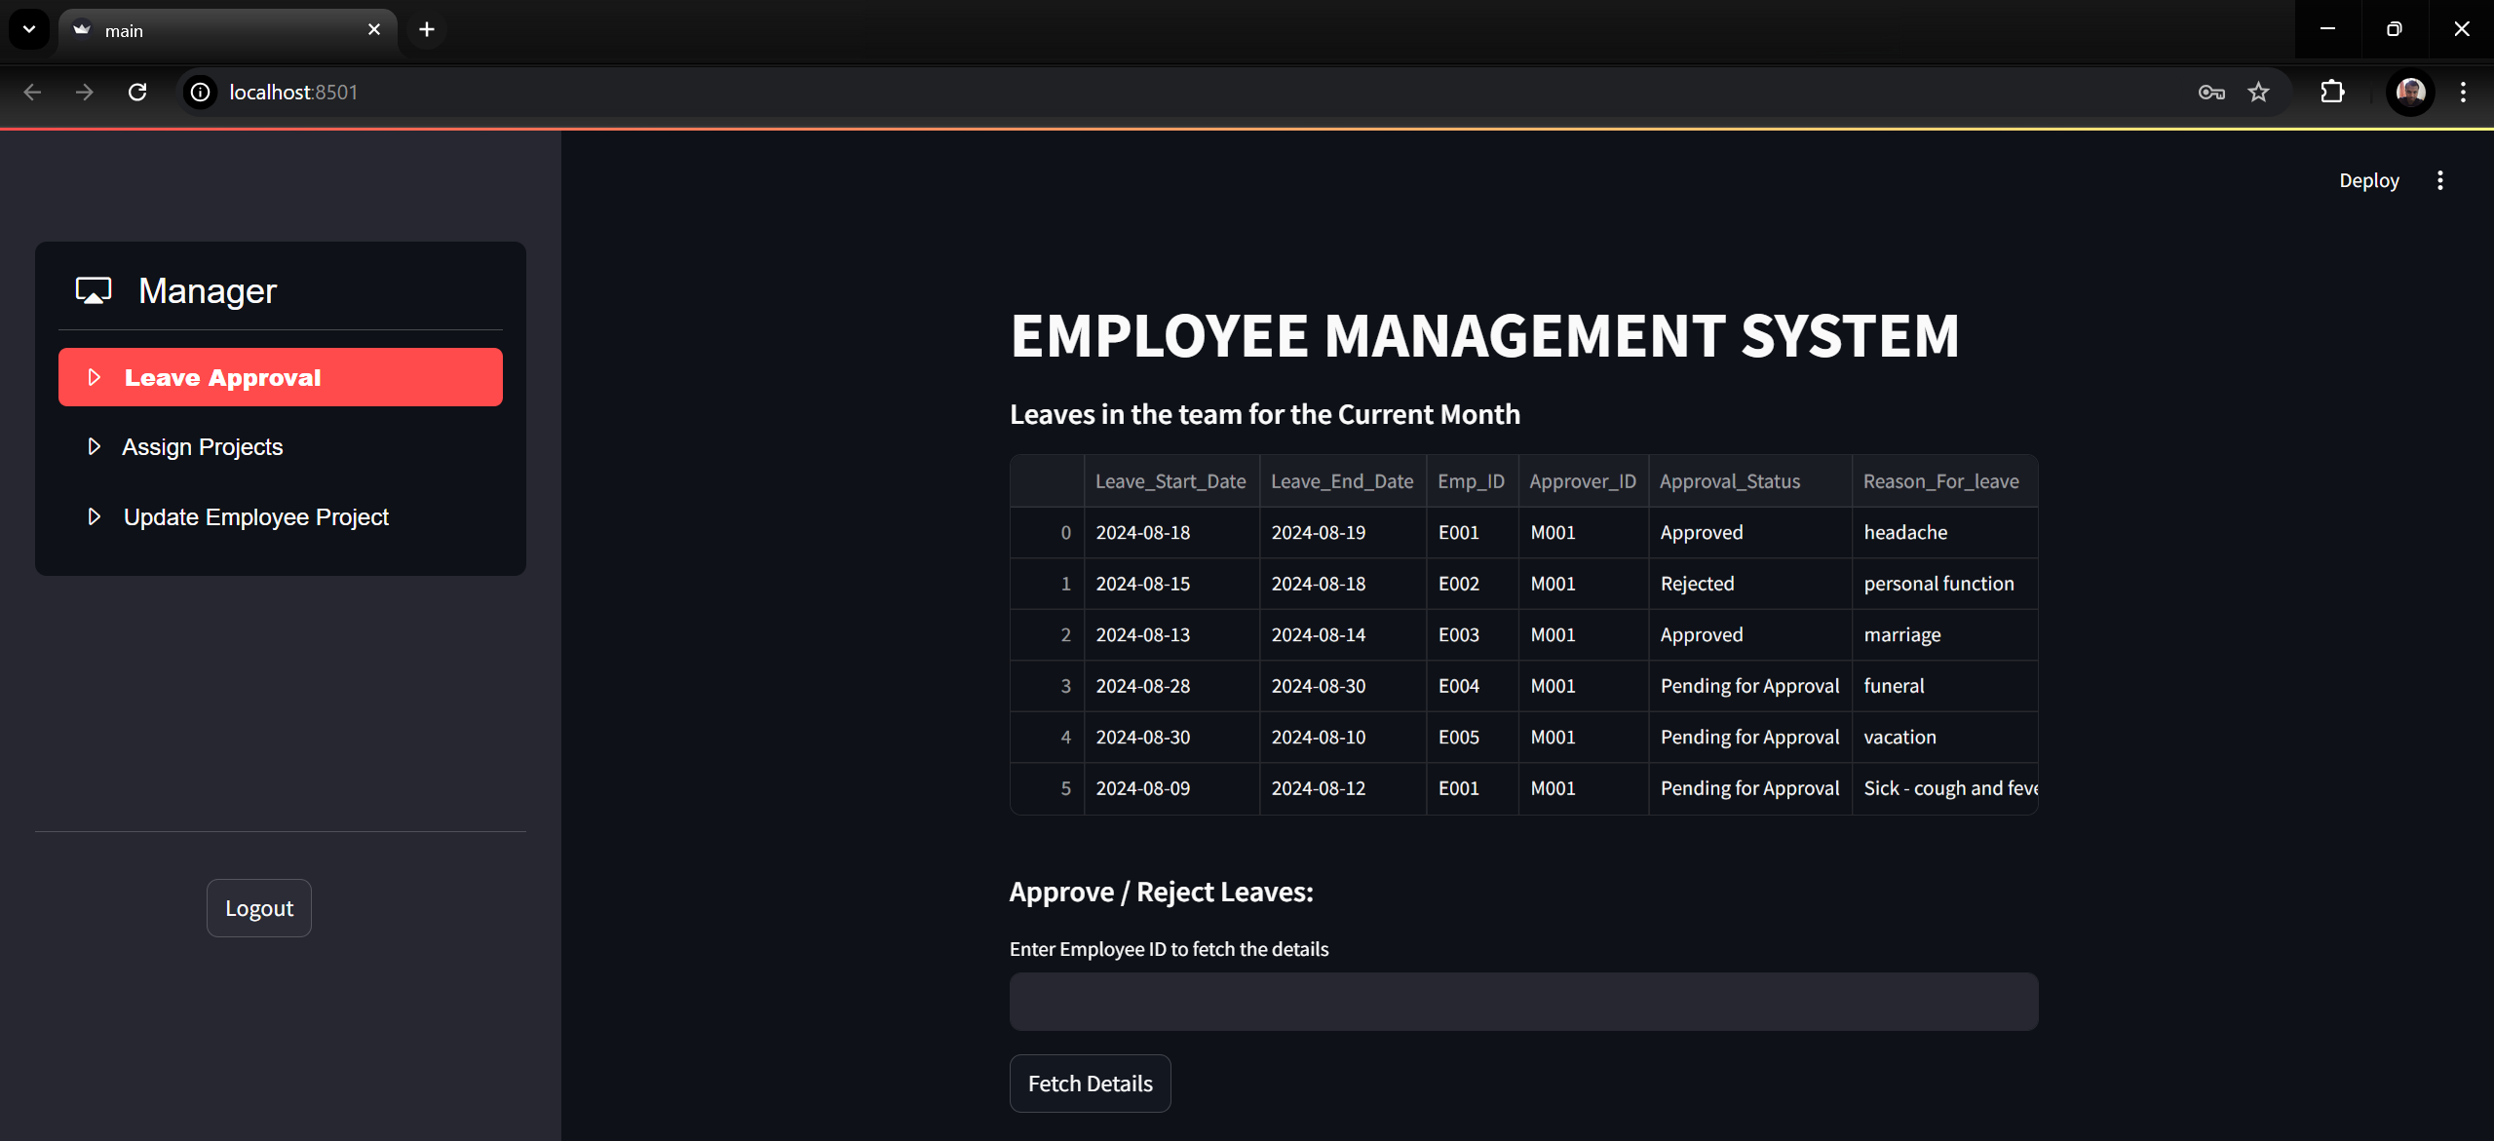

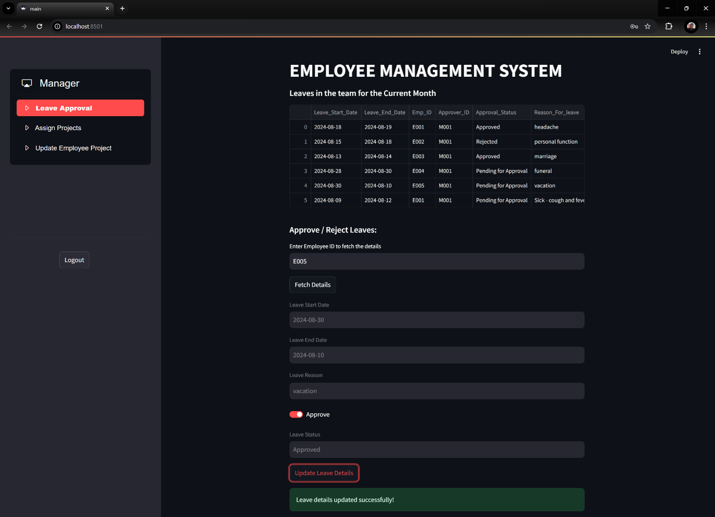

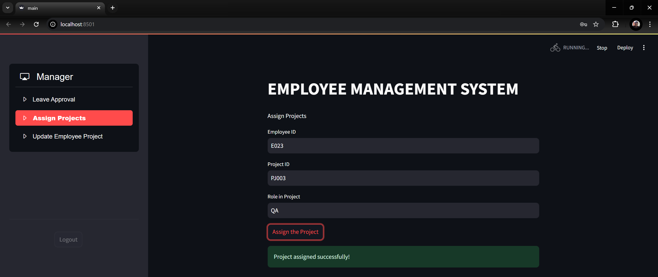

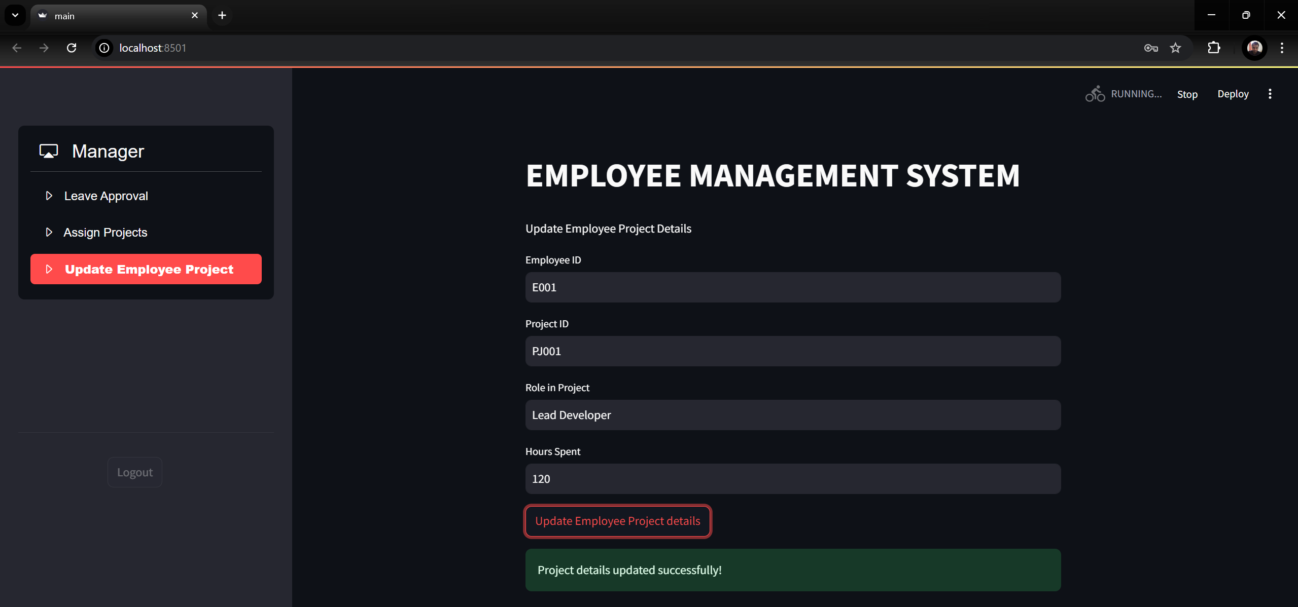

* 1. Project Manager screen: